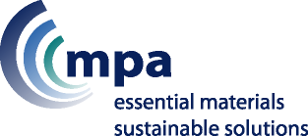
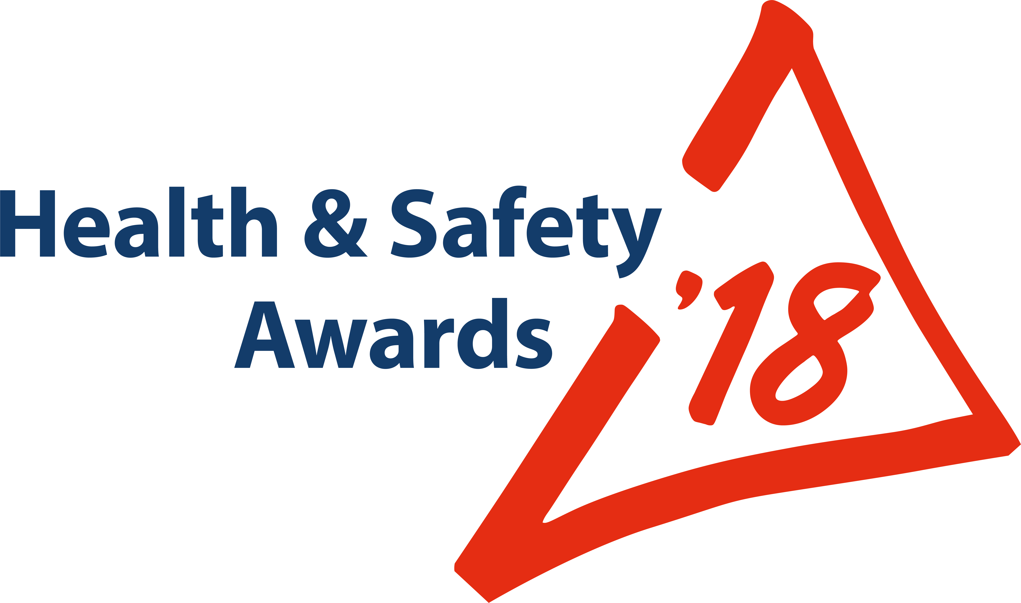
ENTRY FORM
ONLY FOR:
Behavioural Safety; Safety Culture;
Leadership

To enter one of the other categories, download the relevant form from Safequarry.com

Criteria for: “Behavioural Safety; Safety Culture; Leadership” Entries:


The MPQC Trophy will be awarded to the site/company/organisation for the best initiative(s) that clearly demonstrate influence over any aspect of a Behavioural Safety Program or improvement in Safety Culture, both of which are likely to involve the demonstration of strong and effective Leadership which, on its own, may be the subject of your entry.

Below are some of the areas for consideration – the list is not exhaustive:

- Leadership initiatives that demonstrate and focus on instilling lasting safe and healthy behaviours
- Engaging with employees via Health and/or Safety briefing sessions
- Encouraging the giving of workforce feedback; Methods used; Actions taken as a result of feedback
- Coaching ideas used to reinforce safe behaviours and to change at-risk behaviours with individuals and teams
- Effectiveness of coaching by Managers and Supervisors
- Communications: Messaging, such as road shows, newsletters, briefings, use of technology, signage, etc.
- Consultation arrangements
- Method employed to encourage recognition & acknowledgement of safe behaviours by individuals and groups
- How you measure, analyse & communicate reactive and proactive behavioural Key Performance Indicators
- What was particularly new or innovative or evolutionary

Judges will also be looking for those ideas that demonstrate a clear reduction in accidents caused by human behaviour and how those ideas may be readily transferred within and beyond the mineral products industry.

Company Name |  |  |  | Open to all: MPA members; & non-members  Maximum 16 entries overall, per Company  Email this form, attaching photos+captions to: hsawards@mineralproducts.org  BEFORE entering, search www.Safequarry.com for previous similar entries. Your entry needs to be a new idea or innovation, or at least a significant improvement of an existing idea.
Site Name + Postcode
(where entry will be seen by Judges)
Address for correspondence (including post code)
Contact for MPA | Name |  |  | Site Manager  (if different person from ‘Contact’) | Name
Contact for MPA | Email |  |  | Site Manager  (if different person from ‘Contact’) | Email
Contact for MPA | Mobile |  |  | Site Manager  (if different person from ‘Contact’) | Mobile
Entry Ref. No. |  |  | Shortly AFTER you submit your Entry, MPA will supply you with a  unique Reference Number, to be quoted in any further correspondence

Title of your Entry
(15 words max.)

Brief Description; and Benefits following introduction: (suggested maximum: 500 words)

Photographs: 6 high quality images (‘before’ and ‘after’ photographs, if possible)
Attach photographs to your email that you send to MPA to accompany this entry.
Your email to include captions making it clear which caption belongs to which photo.
Please do not embed photos in a ‘Word’ document; image files ONLY (e.g. “.jpg” file size max of 5Mb)

Recognition of Individuals (Optional)  Employees, hauliers, contractors, who have “gone the extra mile” to make this industry even safer and healthier. Your nominee MUST be connected with this entry. | Name & Job Title (ONE NAME ONLY):
 | Brief Summary of REASONS for nomination:

** Entry Deadline 7th April 2018 **

Submit your Entry | Attach this completed form and your photos to an email  Send to: hsawards@mineralproducts.org

