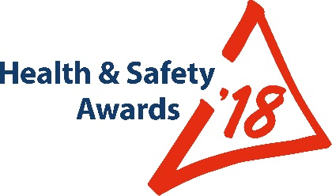
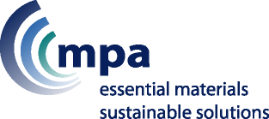
ENTRY
CRITERIA GUIDANCE

For all your entries please demonstrate to the judges where you started, how success was measured, and the final achievement, also consider how you may further develop your submission.

Judges feedback from last year’s awards indicated that there were some very good ideas and initiatives, they just had not been able to develop in the fullness of time.

So a year on please consider those, can you now demonstrate clear progress and achievement, then resubmit them this year.

- Behavioural Safety; Safety Culture; Leadership
- Bitumen; Asphalt; Contract Surfacing
- Contractors’ Safety
- Engineering Initiatives
- Occupational Health and Well-Being
- Reducing Occupational Road Risk
- Transport Initiatives
- Worker Involvement

Behavioural Safety; Safety Culture; Leadership
_______________________________________________________________________________________________

The MPQC Trophy will be awarded to the site/company/organisation for the best initiative(s) that clearly demonstrate influence over any aspect of a Behavioural Safety Program or improvement in Safety Culture, both of which are likely to involve the demonstration of strong and effective Leadership which, on its own, may be the subject of your entry.

Below are some of the areas for consideration – the list is not exhaustive:

- Leadership initiatives that demonstrate and focus on instilling lasting safe and healthy behaviours
- Engaging with employees via Health and/or Safety briefing sessions
- Encouraging the giving of workforce feedback; Methods used; Actions taken as a result of feedback
- Coaching ideas used to reinforce safe behaviours and to change at-risk behaviours with individuals and teams
- Effectiveness of coaching by Managers and Supervisors
- Communications: Messaging, such as road shows, newsletters, briefings, use of technology, signage, etc.
- Consultation arrangements
- Method employed to encourage recognition & acknowledgement of safe behaviours by individuals and groups
- How you measure, analyse & communicate reactive and proactive behavioural Key Performance Indicators
- What was particularly new or innovative or evolutionary

Judges will also be looking for those ideas that demonstrate a clear reduction in accidents caused by human behaviour and how those ideas may be readily transferred within and beyond the mineral products industry.

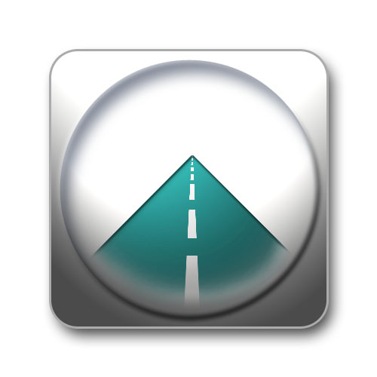
Bitumen; Asphalt; Contract Surfacing
_______________________________________________________________________________________________

The RBA Trophy will be presented to the site/company/organisation within this sector that can clearly demonstrate an initiative, or combination of initiatives, that has had the most success in improving the Health and Safety of its own workforce and/or contractors and/or third parties. Where relevant, this may include protection of members of the public from work-related activities.

Here are just a few examples (not exhaustive):
• Elimination of, or a clear reduction in, risk of injury or occupational ill-health in the sector
• Priority to measures that protect collectively, rather than that protect individuals
• Measures that do not introduce other hazards
• Measures that reduce the need for maintenance
• Measures that reduce the need for working at height

Judges will be looking for your submissions to define:
• What you have done
• Reasons for undertaking the initiative
• The process you followed from concept to implementation
• Who was actively involved
• What was the outcome; Are there ‘before’ & ‘after’ monitoring results
• What was particularly new or innovative or evolutionary

Judges will also be looking for those ideas that demonstrate a clear improvements and how those ideas may be readily transferred within and beyond the mineral products industry.

Contractors’ Safety
_______________________________________________________________________________________________

The BACMI Trophy will be awarded to the site/company/organisation that clearly demonstrates a commitment that has resulted in the most improved contractor safety and/or occupational health, through an individual initiative or combination of initiatives.

Your submission should describe initiatives taken, by you as a Client, OR as a Contractor, OR jointly, to improve contractor safety in your organisation or individual site.

Here are just a few examples of what you might consider in your entry (this list is not exhaustive):
- Approach taken in the selection and monitoring of contractors
- Active monitoring of contractor safety and implementing lessons learned
- Efficient use of MPQC-SPA Contractor Safety passport system to the advantage of Contractor and Client
- How you assess the competence of contractors, sub-contractors and agency workers
- Jointly reducing an identified risk; Jointly providing safer and/or healthier services

Judges will be looking for your submissions to clearly define:
- What you have done
- Reasons for undertaking the initiative
- The process you followed from concept to implementation
- Who was actively involved
- What was the outcome; Are there ‘before’ & ‘after’ monitoring results
- What was particularly new or innovative or evolutionary

Judges will also be looking for those ideas that demonstrate a clear improvement in contractor safety and how those ideas may be readily transferred within and beyond the mineral products industry.

Engineering Initiatives
_______________________________________________________________________________________________

The MPA Trophy will be presented to the site/company/organisation that can clearly demonstrate an innovative or evolutionary engineering design, improvement or solution which has led to the most notable elimination or reduction in the risk of injury and/or occupational ill-health.

The potential of engineering design to reduce or eliminate hazards, at source, is a critical factor in the hierarchy of risk control and is at the very root of the internationally-renowned “Safer by Design” initiative.

Here are a few examples of what you might consider in your entry (this list is not exhaustive):
- A clear reduction to risk of injury and/or occupational ill-health
- Priority to measures which protect collectively over individual measures
- Should be operator and maintenance friendly
- Does not introduce other hazards

Judges will be looking for your submissions to clearly define:
- What you have done
- Reasons for undertaking the improvement
- The process you followed from concept to installation
- Who was actively involved
- What was the outcome; Is the outcome measurable?
- What was particularly new or innovative or evolutionary

Judges will also be looking for those ideas that demonstrate a clear safety improvement and how those ideas and designs may be readily transferred within and beyond the mineral products industry.

Occupational Health and Well-Being
_______________________________________________________________________________________________

The Wimpey Minerals Trophy will be presented to the site/company/organisation that can demonstrate where innovative or evolutionary idea(s) are having the most beneficial impact on the health and/or well-being of all or a particular group of workers, and/or contractors, where appropriate.

This impact should be related to the elimination, or reduction, of a significant workplace health risk. Alternatively, other workplace changes which have had a significant impact on the health/well-being of the work force (e.g. through reduction of sickness absence; rehabilitation; job adjustment and managing employees back into work; good health/lifestyle initiatives) will also be considered.

Some examples or combinations may include (there may be others):
- Health promotion and education
- Automation of a process
- Personal health development and review system
- Recognition and managing stress

Judges will be looking for your submissions to clearly define:
- What you have done
- The reasons for undertaking the initiative
- The process you followed from concept to implementation
- Who was actively involved
- What was the outcome; Are there ‘before’ & ‘after’ monitoring results
- What was particularly new or innovative or evolutionary

Judges will also be looking for organisations that have gone that extra mile to embed Occupational Health and Wellbeing into their business using the initiatives they have identified. Judges will similarly be looking how those ideas may be readily transferred within and beyond the mineral products industry.

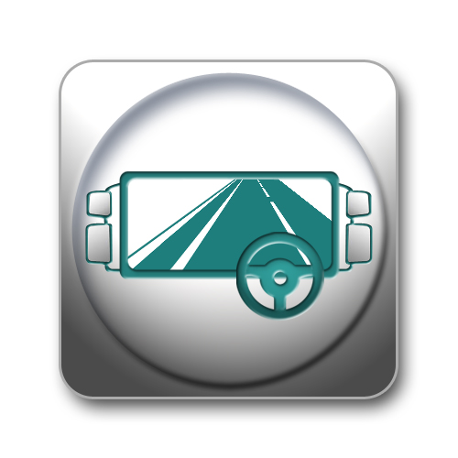
Reducing Occupational Road Risk
_______________________________________________________________________________________________

The TfL Trophy will be presented to the site/company/organisation that has clearly identified the risks and implemented technology, management systems and/or behavioural initiatives to best reduce Occupational On-highway Road isk.

All initiatives must demonstrate direct impact on reducing the risk of road traffic accidents involving some or all transport employees, franchisees, contractors, ‘collect’ drivers, van drivers, and/or car drivers on company business.

Here are some examples of what you might consider in your entry (this list is not exhaustive):
- Driver training and induction
- Communicating with drivers whose first language is not English
- Use of technology; Load security
- Specific driver campaigns
- Systems for managing occupational road risk

Judges will be looking for your submissions to clearly define:
- What you have done
- Reasons for undertaking the improvement
- The process you followed from concept to implementation
- Who was actively involved
- What was the outcome; Is the outcome measurable?
- What was particularly new or innovative or evolutionary

Judges will also be looking for entrants who have gone the ‘extra mile’ to embed a culture of safer driving and how those ideas may be readily transferred within and beyond the mineral products industry.

Transport Initiatives
_______________________________________________________________________________________________

The Blue Circle Trophy will be presented to the site/company/organisation that can clearly demonstrate initiative(s) that have had the most success in reducing or eliminating the risk of injury and/or occupational ill-health.

Here are a few examples of what you might consider in your entry (this list is not exhaustive):
- Traffic management systems
- Reducing or removing the risks from working at height (inspection, securing loads, clean-outs, etc)
- Ensuring accurate and even distribution when loading
- Preventing LGV overturns (vehicle design/maintenance/housekeeping/sticky loads/environmental conditions/etc)
- Aids to vision (all-round vision; front/rear/side view aids; reversing aids/systems
- Reducing slips/trips/falls when entering/exiting LGV cabs

Judges will be looking for your submissions to clearly define:
- What you have done
- Reasons for undertaking the improvement
- The process you followed from concept to implementation
- Who was actively involved
- What was the outcome; Is the outcome measurable?
- What was particularly new or innovative or evolutionary

Judges will also be looking for entrants who have gone the ‘extra mile’ to embed a safer operational culture and how those ideas may be readily transferred within and beyond the mineral products industry.

Worker Involvement
_______________________________________________________________________________________________

The TUC Trophy will be presented to the site/company/organisation that can clearly demonstrate the best initiative led by workers, or that encourages workforce participation, and is proactively monitored and results in positive health and/or safety outcomes.

Here are just a few examples (the list is not exhaustive):
- Management generated & led health and/or safety campaigns that involved workers from the outset
- Workforce led healthier and/or safer working procedures
- Workforce led health &/or safety interventions
- Initiative that demonstrates an improvement in workforce participation

Judges will be looking for your submissions to define:
- What you have done
- Reasons for undertaking the initiative
- The process you followed from concept to implementation
- Who was actively involved
- What was the outcome; Is the outcome measurable
- What was particularly new or innovative or evolutionary

Judges will also be looking for those ideas that demonstrate a clear improvement in worker involvement and how those ideas may be readily transferred within and beyond the mineral products industry.

End.

