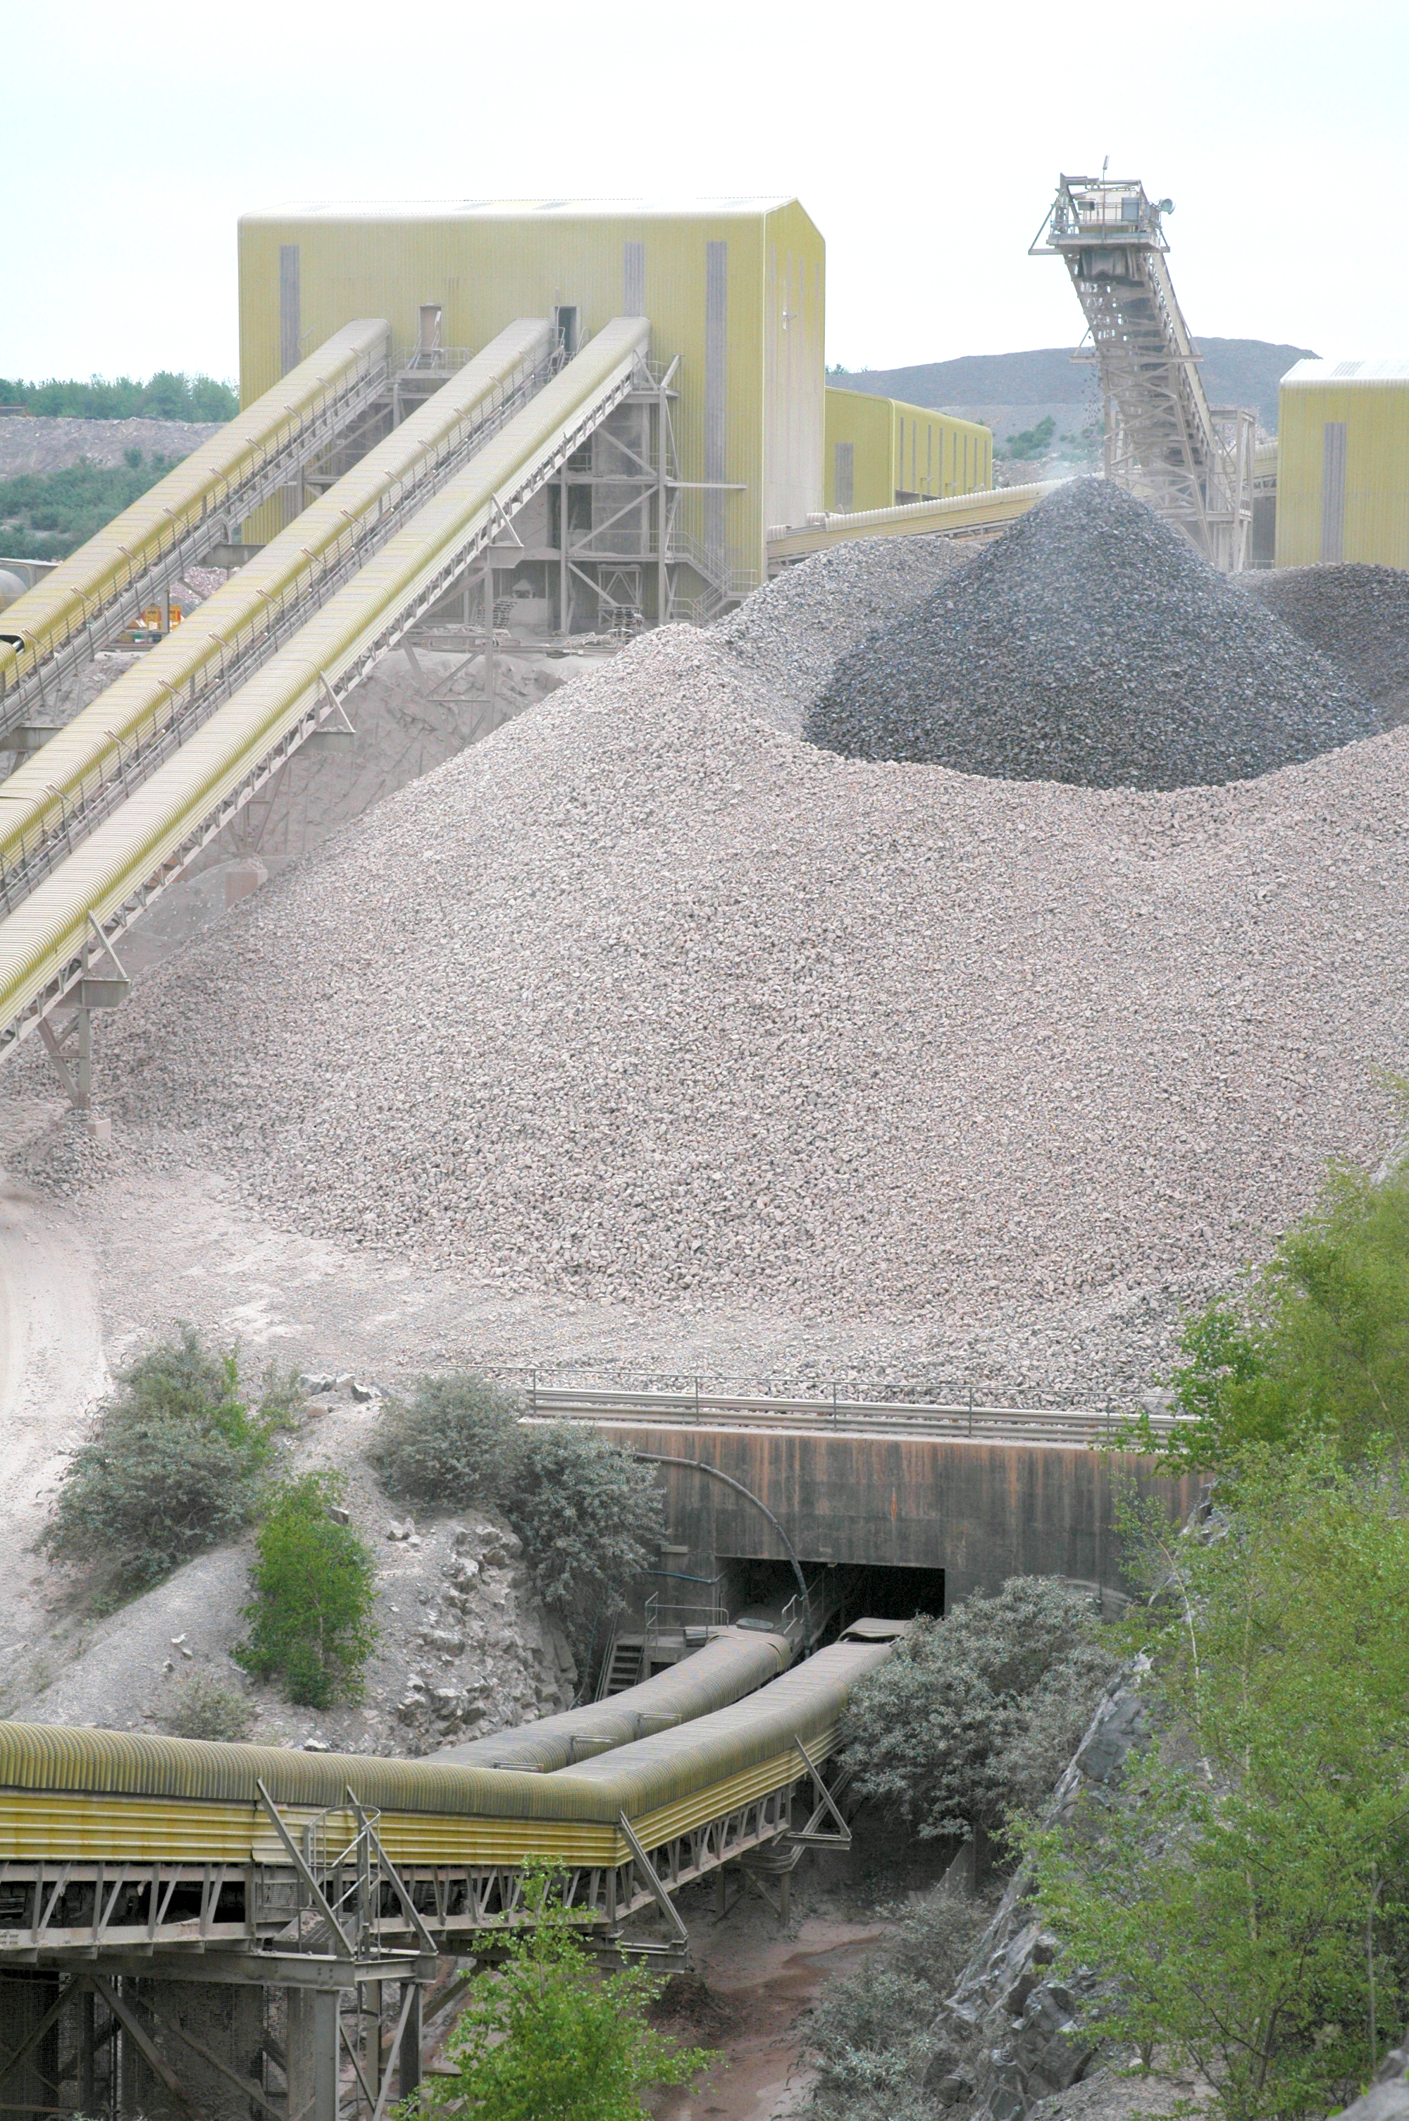  WORKING WITH RESPIRABLE CRYSTALLINE SILICA | This guidance will be included within the ‘Guidance’ chapter in the 2018 edition of the MPA Charter & Member’s Handbook. It was not finalised at the time of publishing this year’s inaugural edition’

Contents
Page No
Introduction 2
Principles for Managing and Reducing Exposure to RCS 2
Supporting Guidance 3
Monitoring Local and Personal Exposure Risks
Healthier by Association 4
Risk Assessment Controlling RCS 4
Immediate and Progressive Protection of Workers
8 Principles of Good Control Practice 6
Maintenance of Controls 7
Housekeeping 7
Personal Hygiene 8
Protective Clothing 8
Selection and Use of Appropriate RPE 9
Storage 9
Maintenance of RPE 10
Positive Education and Health Planning
Information Instruction and Training for RCS 11
RPE Training 11
Monitoring the Effectiveness of Actions Taken
Health Surveillance 13
Respirable Crystalline Silica Exposure Health Surveillance Protocol 13
New Starter Medical 14
On-going Health Surveillance 14
Chest X-Ray Protocol 15
Record Keeping 16
External Health Support 16
Appendices
- Checklist to assist planning 18
- RPE Assigned Protection Factors 21
- References, Further Information & Glossary 22

Introduction

MPA members are committed to achieving Zero Harm; this target is applicable to both safety and health. There is a recognised health risk for those within our industry who are exposed to work-generated Respirable Crystalline Silica (RCS) particles. It is widely recognised that by applying correct controls, the health risks to all persons, both directly and indirectly employed, can be mitigated.

Members involved in the production of materials that contain crystalline silica in any form, which may be cut, crushed, milled or ground in the production processes (workplace generated dust) must take all actions as low as is reasonably practicable to protect their workforce from over exposure. The end user should also consider in their risk assessment the hierarchy of control defined in the Control of Substances Hazardous to Health (COSHH) when selecting the appropriate control measures to reduce the risk of exposure. This maybe in the form of local extraction and effective filtration, suppression of particles through fine wet mist applications or ultimately to supplement previous mentioned control measures with RPE to reduce levels further. The following guidance will assist members to decide on the appropriate methods of management and risk controls applicable to their own operations and risk profile.

Key Principles for Managing and Reducing Exposure to RCS

MPA’s Health & Safety Committee strongly recommends using the following principles in order to minimise and manage the exposure of individuals to RCS;

  - Leadership - Nominate an individual within each member company that will drive the improvement by reducing exposure through a ‘champion’ ‘continuous improvement’ or team approach.

  - Audit- Undertake a baseline Healthier by Association RCS Audit, to determine the current position and provide an appropriate action plan for the nine key areas.

  - Risk Assessment - Understand the geology of the product being extracted and or processed and conduct a risk assessment. Apply a risk factor associated to the silica content of the material, and decide on the appropriate degree of control required using the COSHH hierarchy.

  - Education – Ensure that all employees are fully aware of the health hazards associated with exposure to RCS and informed of measurements made of airborne concentrations. Train all employees in developed procedures and the importance of using the appropriate control measures provided.

  - Monitoring – Conduct appropriate proportionate personal and static dust monitoring where determined by the risk assessment mentioned in 3 above.

  - Health Surveillance – Put in place the MPA recommended, or equivalent, standard for RCS Health Surveillance. To further support this, MPA strongly advocates the use of chest x-rays to diagnose potential cases of silicosis and or other respiratory disease at the earliest opportunity.

  - Review - Following the base line audit, carry out a periodic review at least every two years to maintain a programme of continuous improvement.

Supporting Guidance

To assist members in achieving the above, the following non-exhaustive guidance has been produced. This has been broken down into 4 sections, as illustrated and summarised in the diagram below. Further in depth guidance can be found within each of the relevant colour coded sections.

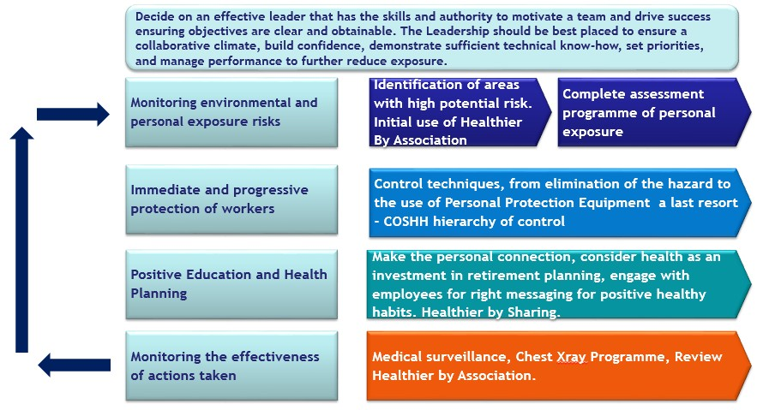

Monitoring Local and Personal Exposure Risks

Healthier by Association Tools

The Healthier by Association Audit gives the user the opportunity to conduct an in house systematic initial, ongoing and periodic review of how your management systems control the exposure of employees to dust.

The Audit contain questions on the 7 key principles of this document identifying the strengths and opportunities for improvements. On completion, a radar chart and action plan is produced this will assist RCS Teams, Champions etc too set clear objectives which should be reviewed on an annual basis. In doing so will demonstrate continuous improvement or maintaining an acceptable level of compliance and reduction in exposure.

The Healthier by Association Excel Workbook is freely downloadable from www.safequarry.com & www.safeprecast.com. The MPA principles of Safer & Healthier by Association can also broker further in house competent advice from other member companies to assist them in meeting their own objectives.
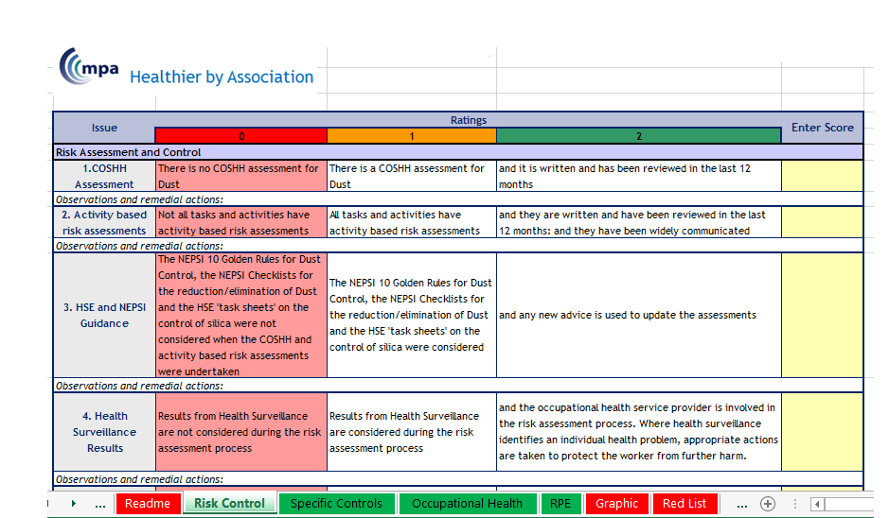
Image above shows Page 1 from the Audit

Risk Assessment Controlling RCS
The foundation to managing any risk is the completion of suitable and sufficient assessments. Every site should have conducted assessments, these maybe in the form of a COSHH assessment, that are referenced for each job or range of tasks in an activity/task based risk assessment.

The content of your assessments should include the following:

- Potential for exposure – examine all tasks, not forgetting non-routine work (breakdowns, etc.);

- Examination of any existing engineering and management controls;

- Effectiveness of any existing controls can be confirmed by using survey information, and/or by the use of dust lamp;

- Identify where further engineering controls are necessary (i.e. what needs to be done to achieve and sustain adequate control to demonstrate that emissions, if not eliminated, are as low as reasonably practicable (ALARP);

- Use of respiratory protective equipment, of an appropriate type, at any particular location or task;

- Maintenance, examination and testing of engineering controls;

- Monitoring;

- Health surveillance;

- Specify the information, instruction and training required for employees.

Where applicable, ensure that the risk assessment is not reliant on generic content; specify the risk assessment to your exact circumstances and working practices in your company.

Respirable crystalline silica (RCS) is assigned a workplace exposure limit (WEL) of 0.1 mg/m³. A sampling regime should therefore be instigated to demonstrate and record your legal compliance. Additionally, a personal sampling regime will establish your base line conditions, demonstrate the effectiveness of any control measures installed, and show where there may be a deterioration in safe systems of work - all further supporting your risk assessment process.

In general, the use of personal sampling (that is, with the sampling instrument attached to the employee or contractor) rather than fixed-point sampling (sampling at a particular location) is the only method likely to give an accurate picture of the level of exposure for the individual. Sampling surveys should be conducted by a competent person able to analyse results, report on their findings and make recommendations. Static sampling records should be held for 5 years and personal sampling for 40 years.

A sampling survey in isolation does not constitute a risk assessment. The assessment and any resulting systems of work should be presented in a way that is readily understandable by your workforce and those who are affected. You should retain records showing that these documents have been presented to them and they have read and understood its contents. The record should be signed and dated for each affected person, including when any refresher training has been conducted.

Immediate and Progressive Protection of Workers
In order to reduce exposure to as low as is reasonably practicable (ALARP), COSHH Regulation 7 makes provisions for prevention and control of exposure. In particular, COSHH Regulation 7(7)
(a) Schedule 2A refers to 8 principles of good control practice (below) and these should be applied to reduce exposure to respirable crystalline silica. A variety of control options may have to be employed.

HSE “COSHH Essentials for Silica” sheets give details of good practice control options to reduce exposure to silica (see Appendix 2). If you are unsure of the control options for your site, you should consult your local occupational hygienist or health and safety advisor for clarification or assistance.

Principles of Good Control Practice (COSHH Regulation 7(7) Schedule 2A)

- Design and operate processes and activities to minimise emission, release and spread of substances hazardous to health.

- Take into account all relevant routes of exposure – inhalation, skin absorption and ingestion – when developing control measures.

- Control exposure by measures that are proportionate to the health risk.

- Choose the most effective and reliable control options which minimise the escape and spread of substances hazardous to health.

- Where adequate control of exposure cannot be achieved by other means, provide, in combination with other control measures, suitable personal respiratory protective equipment.

- Check and review regularly all elements of control measures for their continuing effectiveness.

- Inform and train all employees on the hazards and risks from the substances with which they work and the use of control measures developed to minimise the risks.

- Ensure that the introduction of control measures does not increase the overall risk to health and safety.

These 8 principles are further supported through guidance in the COSHH Essentials series, specifically ‘QY - COSHH Essentials in Quarries: Silica’, which can be found at http://www.hse.gov.uk/pubns/guidance/qyseries.htm The principles found in this series of documentation are the minimum expected standards to be applied and which inspectors will assess against. A critical factor to the effectiveness of using the COSHH Essentials is that they are used together rather than cherry picking. ‘COSHH Essentials QY 0’ provides a good foundation to managing RCS.

Maintenance of Controls
Any control measures introduced should be checked and maintained to ensure that they continue to be effective and the control measures introduced should not increase the overall risk.

Even the most modern and most capable exhaust ventilation system will very rapidly lose its efficiency if it is not regularly cleaned and maintained.

You should establish a maintenance, inspection and cleaning schedule for the concerned system parts, at specified intervals alongside responsibilities. The system should be tested for operability in each case before starting work. Prior to the first commissioning and after major modifications, the exhaust ventilation system should be tested by a qualified person for sound installation, function and set-up. Any Local Exhaust Ventilation (LEV) installed should be thoroughly examined and tested every 14 months.

If installing such a system for the first time, be sure to measure RCS exposure ‘before’ and ‘after’ in order to demonstrate the benefit derived from the new system.

Other considerations for the control of exposure in the quarry may also include combinations of the following and should be subject to recorded scheduled maintenance and testing for efficiency:

- Dust collectors on drill-rigs;

- Water addition to the air line;

- Water suppression sprays or atomising/fogging systems;

- Screen hoods;

- Encapsulation;

- Extraction systems; Local Exhaust Ventilation (LEV)

- Dust extraction/collection equipment;

- Integral units;

- Positive pressurisation of cabs on mobile equipment;

- Road and stockpile damping.

The COSHH Essentials general series, specifically QY 0 to 11, provide a good information base for many of these areas.

Housekeeping
Housekeeping in general should be considered a priority where processes create potential for high dust concentrations. These areas should be segregated and signs erected showing authorised entry only by wearers of appropriate RPE.

Many airborne dust problems result from spillage that is not cleaned up. Other areas of concern are lying dust on purlings, steel framework and control panels etc. Any of these indicators are obvious demonstrations as to the inefficiency of local exhaust and ventilation in general, prompting the need for further investigation and remedial action. Lying dust can be moved in turbulent air caused by vehicle movement, vibration and sudden impact, increasing airborne dust concentration levels.

Where consistent spillage requires cleaning a focus should be given to understanding and finding the root cause of the problem and providing solutions to preventing the spillage in the first instance.

Areas should be regularly cleaned and prevention of further airborne contamination should carried out by vacuuming or wetting down. The use of brooms and shovels should be avoided. ‘COSHH Essentials QY 10’ provides a good foundation to the expected controls in these areas.

Another important factor to consider is to ensure a consistent approach to housekeeping and maintenance of mobile plant cabs and plant control rooms. Conditions that cause concern are the use of cloth covered seats harbouring fine respirable dust particles. These become airborne each time a person sits on the seat. Wipe clean, non-woven fibre materials should be used. General cleanliness is degraded when materials are brought into the cab or cabin on boots, for example. These materials dry out and become airborne.

Similarly, where old documents, newspapers, magazines, etc., are left lying around, these gather respirable dust particles. Regular inspection and diarised records should be maintained. ‘COSHH Essentials QY 11’ provides a good foundation to the expected controls in these areas.

Personal Hygiene
The following personal hygiene practices are essential for protecting workers from respirable crystalline silica:

- Do not eat, drink, or smoke in dusty areas.

- Wash hands and face before eating, drinking, or smoking outside dusty areas.

- Change overalls before accessing welfare facilities.

Protective Clothing
Modern fabrics are less likely to retain dust than cotton overalls and suitable overalls should be selected on their dust retention and release characteristics. Take the following steps to assure that dusty clothes do not contaminate cars, homes, or workplace outside the dusty area:

- Change into disposable or washable work clothes at the workplace.

- Shower and change into clean clothes before leaving the workplace.

Selection and Use of Appropriate RPE
Employers are responsible for selecting, implementing and managing the use of adequate and suitable RPE. This includes ensuring the correct type is chosen, sufficient training is given and that use is then monitored and enforced.

After the application of the Hierarchy of Controls through risk assessment, it is likely RPE will be a last control. However, where exposure is likely to be high over long durations, other controls such as LEV is expected.

Where RPE is used as a control measure, it is vital that it is adequate and suitable. RPE must reduce exposure to as low as reasonably practicable levels, and in any case to an acceptable level (e.g. below any applicable Workplace Exposure Limits or Control Limits (WEL)).

For RPE to be suitable it must be matched to the job, the environment, the anticipated airborne contaminant exposure level, and the wearer. Unless your occupational monitoring indicates otherwise, the minimum standard of RPE for RCS will have an assigned protection factor (APF) of 40.

APFs are assigned to each type of RPE and can be located on the serial data on the box or RPE itself. The higher the APF number the greater the protection. See Appendix 1 for comparison and explanation.

Different types are available such as full face mask, powered hood, helmet or blouse model; and power-assisted full face mask model, which you choose will depend on your risk assessment.

Further, as facial features come in all sorts of shapes and sizes, it is unlikely that one particular type or size of RPE face piece, will fit everyone. Fit testing will help ensure that the equipment selected is suitable for the wearer.

RPE fit testing should be conducted by a competent person. Competence can be demonstrated through achieving accreditation under the ‘Fit2Fit RPE Fit Test Providers Accreditation Scheme’. This Scheme has been developed by the British Safety Industry Federation (BSIF) together with industry stakeholders and is supported by HSE. The scheme is not compulsory and employers are free to take other action to comply with the law. Further details on the scheme can be found at the web site www.fit2fit.org

Fit test reports should be available for all employees who wear RPE incorporating tight-fitting face pieces. Fit test records should be retained and made available for inspection on request.

Storage
Clean, hygienic storage facilities that are accessible to enable easy use should be provided, such as sealed cabinets near the work area. The RPE should be cleaned before putting away to prevent the storage area becoming contaminated. It is therefore important to ensure that required materials to keep the RPE clean are accessible and convenient.

Manufacturer’s instructions should be followed to ensure RPE is stored in a manner which prevents contamination, damage and deterioration.

Maintenance of RPE
Other than disposable half masks, RPE should be examined and tested at least every 3 months, and more frequently where the environment and use demonstrate a decreasing efficiency in the protection.

Maintenance should be undertaken by a competent person and it is prudent to keep a small stock of consumable parts to ensure easy maintenance and replacement of elements as they expire, such as filters. All replacement parts should be sourced from the original supplier to ensure compatibility and continued effectiveness. Users should do a pre-use check of the RPE to ensure that it is operational.

Reference should also be made to the manufacturer’s recommendations and schedules. Records of all testing and maintenance must be kept for 5 years.

Positive Education and Health Planning

Information Instruction and Training for RCS

Employers are responsible for ensuring that their employees receive suitable and sufficient information instruction and training to ensure their health and safety, including RCS.

Safequarry.com provides a number of resources to aid employers in providing staff Information Instruction and Training on RCS. The Quarries Partnership Team, in particular, provides a number of resources which can be found at
http://www.safequarry.com/qpt.aspx.

The European Network on Silica – NEPSI also provides ‘Detailed Task Sheets’ these provide a set of detailed technical recommendations to reduce exposure in the specific industrial settings encountered in each of the signatory industries.

They can be found at http://www.nepsi.eu/good-practice-guide

It is recommended that Information Instruction and Training provided should consist of the following:

- The risks associated with exposure to RCS

- The suitable methods of work

- The correct use and maintenance of the control measures in place

- The correct use and maintenance of any respiratory protective equipment (RPE) provided

- Health surveillance provided.

You should ensure that the information, instruction and training provided is relevant to your employees & contractors, as well as being appropriate to the level, type and duration of exposure identified by the risk assessment.

The table, below, lists a set of key information instruction and training resources, further to this, however, the employer should ensure that employees are:

- aware of health surveillance results, risk assessment findings, COSHH assessment findings and how to follow the safe system of work.

- have understood the information, instruction and training delivered and are applying the lessons learnt through simple assessments and behavioural observations, inspections and audits.

RPE Training

Once suitable RPE is selected and face fitted to the individual, that individual’s competency must be assured. The individual must be given suitable information, instruction and training on:

- Why RPE is needed;

- The hazards, risks and effects of exposure;

- What RPE is being provided;

- How RPE works, why fit testing is required, how to wear and check the RPE correctly;

- Fit checking before use, ensuring wearers remain clean shaven, what maintenance is required and when, where and how it should be cleaned and stored;

- How to report/tackle any problems;

- Employee and employer responsibilities;

- Use and misuse of RPE.

Monitoring the Effectiveness of Actions Taken

Health Surveillance
A high level of health surveillance is required for all employees who routinely work with materials that have the potential to release RCS when processed or moved or subject to entrainment by wind. It should be provided by a recognised health professional and may include the following:

- Assessing respiratory health prior to employment in pre-employment screening;

- Regular tests involving questionnaires, lung function tests and, if recommended by occupational health physicians, chest X-rays;

- Health records are to be securely and confidentially retained for 40 years.

The MPA strongly recommends that members use the Respirable Crystalline Silica Exposure Health Surveillance Protocol dated 13th September 2016. To assist members, the MPA, in
conjunction with Industrial Diagnostics Company (IDC), have developed a mobile service that can be used in conjunction with other members on a regional basis at strategically key members’ operational facilities.

Refer to COSHH Essentials General Guidance G404 ‘Health Surveillance for Those Exposed to Respirable Crystalline Silica (RCS)’ for further guidance.

Respirable Crystalline Silica Exposure Health Surveillance Protocol

The MPA Health and Safety Committee strongly supports the following protocol, which not only allows early detection of potential debilitating silicosis, but also the early diagnosis of other respiratory disease that can benefit both the employer and the employee investing in Health.

The following guidance document supports MPA’s position on controlling the effects of exposure to Respirable Crystalline Silica (RCS) and its wider agenda to improve and support its zero harm initiative including its proactive approach to the health agenda.

The purpose of this protocol is:
- To identify those employees whose history and medical opinion has supported a diagnosis of silicosis or other occupational lung disease and to ensure that these employees are not exposed to future occupational risk that may cause worsening of the condition.

- To give employees the opportunity to raise any concerns about the effect of their work on their lung health.

- To provide an opportunity to advise employees further in safe and healthy working practices, for example the importance of wearing respiratory protective equipment (RPE) properly and the need to be clean shaven for close fitting face-pieces to work effectively to protect the lungs.

- To provide further guidance on the implementation of the Health Surveillance for those exposed to (RCS – Supplementary Guidance for Occupational Health Professionals. Health and Safety Executive, amended January 2016.

New entrants to the industry who have not historically been exposed to RCS in a work environment and whose new role will involve exposure to RCS dust (in accordance with the assessment of risk listed below) will need to participate in baseline health surveillance for RCS.
If a person is joining the business from another industry where they have been subjected to RCS health surveillance that included chest x-rays (CXRs), consent should be sought by the occupational health provider (OHP) for access to previous chest x-ray results based on screening specifically for silicosis and/or occupational purposes. The timeframe for on-going surveillance should be calculated from the previous chest x-ray date and recorded to demonstrate the reasons behind the calculation. Failure to provide consent will automatically enrol employees in the process as detailed below.

An assessment of risk for pre-existing employees may include the following:
- Historical and current exposure to RCS of 15 years or more with results at or above 75% of the workplace exposure limit (WEL) 0.075 mg/m3 - 0.1 mg/m3 being a trigger for entering into a chest x-ray programme (PA CXR).
- Reliance on Respiratory Protective Equipment (RPE) as an exposure control measure.
This protocol applies to all employees identified as having been exposed to RCS.

New Starter Medical
Baseline Health Data – for all new employees exposed to RCS as per the above assessment
- Respiratory Questionnaire (as per the template included in ‘Health Surveillance for those exposed to Respirable Crystalline (RCS) – Supplementary Guidance for Occupational Health Professionals’, Health and Safety Executive, amended January 2016).
- Lung function testing (FEV). These tests measure how much air a person can exhale during a forced breath. With regards to RCS, the FVC (the total amount of air exhaled during the FEV test) and the FEV1 (the amount of air exhaled may be measured during the first or second exhalation) are the important measurements because the calculated ratio is used in the diagnosis of obstructive and restrictive lung disease.
- Concerns should result in escalation to an Occupational Health Physician (OHP) in order to obtain further advice on fitness for work.

On-going Health Surveillance
After new starters have completed their probation period and before one year’s exposure for existing employees

- PA CXR. (Posterior and anterior chest x-ray, i.e. an x-ray of the front and the back of the chest cavity).
- A report back from the OHP to advise on the findings of the chest x-ray.

Years 2 - 14 annually
- Respiratory questionnaire F-CG-013
- Pulmonary Function Testing (FVC, FEV1)
- Concerns should result in escalation to an OHP in order to obtain further advice on fitness for work.
- (Note no CXR unless specifically recommended by the OHP)

or all employees who have been exposed to RCS for 15 years
- Respiratory questionnaire F-CG-013
- Pulmonary Function Testing (FVC, FEV1)
- PA CXR on year 15.
- PA CXR every 3 years after the 15th year of exposure to RCS.
- Concerns should result in escalation to an OHP in order to obtain further advice on fitness for work.

Abnormal Spirometry
Refer to OHP if;
- FEV1/FVC less than 70%
- FEV1 and/or FVC less than 80% of predicted
- Decrease in FEV1 of more than 500mls in 1 year Decrease in FEV1 of more than 500mls over 5 years

CXR protocol
If there are occupational concerns regarding the baseline PA CXR, a further PA CXR should be undertaken at one year. Non-occupational concerns should always be referred to the employee’s GP.
Note that this timescale is independent from employers and should be calculated from the total time of the employee’s exposure to RCS. A record of how this timescale has been calculated should be retained in personnel records.
This period should only be breached or reduced at the request of an OHP. The OHP may request CXR outside the normal protocol if concerns arise from on-going health screening.
CXR should be read by a consultant Radiologist who has been informed that employee has been referred as part of an RCS health surveillance programme. The expectation is that the PA CXR will be reported against the ILO standard (International Labour Office Standard for chest abnormality classification).

If CXR at year 1 shows opacities (a change in the appearance of normal lung tissue) at ILO grade 0/1 it will be repeated at year 2. If no progression, then no further routine CXR until year 15.
If CXR at year 15 shows opacities at ILO grade 0/1 then routine 3 yearly CXR should be indicated.
If CXR shows any opacities above grade 1/0, at any point, the employee will be referred to a respiratory specialist with experience in occupational lung disease.

PA CXR result outcomes
From the initial x-ray screening program, there are 5 potential outcomes:
- Nothing abnormal discovered;
- Supportive of known medical condition (e.g. the individual has an abnormal PA CXR that supports a known work related medical condition of the lung e.g. pneumonia or TB);
- Abnormal PACXR. Not suspicious of occupational lung disease but requires further investigation via employees GP;
- Requires further investigation for occupational lung disease;
- Recommend a repeat chest PA CXR (poor quality, part of lung missing on the x-ray etc.).
Employees with suspected respiratory disease related to RCS exposure must be reviewed by an OHP, who will provide advice on review and fitness for work. Outcomes 3-5 may cause concern and worry for employees, and therefore OHP’s should work in collaboration with HR and line managers to ensure that results and the timeliness of results are managed sensitively.

Record Keeping
All results of personal exposure to RCS and RCS health surveillance results including results from previous employment that have contributed to the decisions made regarding frequency of PA CXRs must be retained within personnel files for 40 years.
Your occupational health provider will retain medical records for 40 years.

External Health Support
MPA have partnered with the Industrial Diagnostics Company an MPA member to offer an on- site service delivered from members’ premises in which up to 40 employees can be seen per day and lost production time is minimised. State of the art digital imaging equipment is used to detect the earliest signs of Silicosis, whilst all other abnormalities detected from CXRs are also referred for medical advice.
Part of this process is to also gain consent from employees willing to allow their CXRs to be fully anonymised and used for research into Occupational Lung Disease as part of the largest cohort of currently exposed employees, in order to help develop a clearer picture of the potential for the numbers of evidenced base silicosis cases within our industry. There remains

currently a significant lack of fundamental understanding of the facts and the use of estimates of those likely to contract silicosis from historical data from death certificates.
IDC’s mobile on-site CXR service will be unbranded and can be delivered either in conjunction with IDC Occupational Health Surveillance or as a stand-alone service alongside company’s current OHPs.
In addition to the provision of the on-site service, it was confirmed that IDC and the MPA will provide details of national screening clinics around the country, enabling members’ employees to attend local facilities for their CXR. This will be particularly beneficial for SMEs in that sites with small numbers of exposed employees will be able to be seen at the same cost as sites with larger numbers of employees who require the service. The national screening clinics will also serve as a ‘mop-up’ service for larger companies that have used the mobile on-site service where a small number of employees could not attend who require a repeat CXR.
Up and coming national screening clinics would be advertised by the MPA at each regional and product group meetings. Employers would be able to book employees on to specific sessions at scheduled times at suitable geographical locations to assist with cost and travel times.

Appendix 1

Assessing the Risk General Checklist

Action | Yes | No | Comments and Further Action Required
Have you completed a Healthier by Association audit?
Have you conducted a COSHH Assessment based on RCS and reviewed in the last 12 months?
Have you conducted activity risk assessments for all your tasks and activities and reviewed in the last 12 months?
Have you produced relevant safe systems of work have these been reviewed in the last 12 months?
Has static and personal air monitoring been conducted in the last 12 months?
Have all high risk processing areas been identified and adequately signed?
Are control cabins, mobile plant cabs and welfare facilities regularly monitored for cleanliness and recorded?
Are incoming filtration systems supplying control cabins, mobile plant cabs subject to regular maintenance and recording?
Are LEV and general ventilation systems checked to manufacturer’s operational standards and every 14 months in line with COSHH regulations records held and any actions signed completed?
Has Health Surveillance been conducted in the last 12 months?
Do you have dust reduction teams in place to prevent/ reduce dust exposure and spillage?
Have you put a housekeeping schedule in place?
Information Instruction and Training Checklist

Action | Yes | No | Comment and Further Action Required
Have you informed employees of activity risk assessment findings and resultant controls?
Have you informed employees of COSHH assessment findings and resultant controls?
Have you trained employees on following relevant safe systems of work?
Have you trained employees in the risks associated with exposure to RCS?
Health surveillance to be provided.
Do you hold records of all training completed?
Videos Available on Safe Quarry.com:

- Stop Dust Before it Stops You
- Don’t be a Dummy – Stone Dust and Silica
- Dust and Fumes Occupational Health
- Dust and laboratory work Video
- Dust and local exhaust ventilation
- Dust and maintenance
- Dust and the crushing of minerals
- Dust water assisted dust suppression when cutting and grinding
- Health on Site Occupational Health
- Preventing contact with hazardous substances COSHH
- Quarry Dust - are you in control – Power Point Presentation with speakers notes and video clips
- Quarry Dust - are you in control - Silica routes of entry - including animation of effect on lungs
- Quarry Dust - are you in control - Speakers notes
- Quarry Dust - are you in control - Video clip for presentation - sanding with light
Do you check employees understand what they have been instructed or trained on, by:
- Assessments
- Inspections
- Audits
- Behavioural observations

Respiratory Protective Equipment Checklist

Action | Yes | No | Comments and Further Actions Required
Do you have a policy for selecting, implementing and managing the use of RPE?
Have you identified and selected RPE based on risk assessment and occupational monitoring and to the correct protection factor?
Have you undertaken fit testing for wearers?
Is fit testing undertaken by a competent person?
Are records available for fit testing?
Are wearers given suitable information, instruction and training on:
- Why RPE is needed
- The hazards, risks and effects of exposure
- What RPE is being provided
- How RPE works, why fit testing is required, how to wear and check the RPE correctly,

- Fit check before use, maintenance required
when, where and how it should be cleaned and stored,
- How to report/tackle any problems,
- Employee and employer responsibilities,
- Use and misuse of RPE.
Do you provide suitable clean storage facilities for RPE?
Are materials for keeping RPE clean accessible?
Is RPE examined and tested at least every 3 months or more frequently where required?
Is maintenance undertaken by a competent person?
Do you keep a small stock of consumable parts to ensure easy maintenance and the replacement of parts?
Do users undertake a pre-use check on their RPE before use?
Are all records of all testing and maintenance kept for 5 years?
Do managers and supervisors check the correct use of RPE and application of the RPE policy?

Monitoring & Occupational Health Surveillance

Action | Yes | No | Comments and Further Actions Required
Have you appointed competent occupational health provision and advice?
Do you have a policy and plan for monitoring personal exposure from workplace generated respirable crystalline silica dust?
Do you have a policy for health surveillance for those exposed to respirable crystalline silica dust?
Do you have record keeping facilities available for 40 years?
Have you Identified higher risk activities and locations?
Are reports and plans collectively reviewed annually?

Appendix 2 Assigned Protection Factors

The Standard Defines Assigned Protection Factors as...

"Level of respiratory protection that can realistically be expected to be achieved in the workplace by 95% of adequately trained and supervised wearers using a properly functioning and correctly fitted respiratory protective device."

EN529, Recommendations for selection, use, care and maintenance, shows the following information:

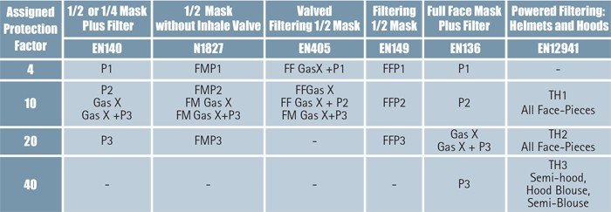

Appendix 3 References and Further Information

Glossary
COPD - chronic obstructive pulmonary disease CXR – Chest X-ray
PA CXR – Posterior to Anterior Chest X-ray is performed standing and in full inspiration OHP – Occupational Health Provider
RCS – Respirable Crystalline Silica
RPE – Respiratory Protective Equipment WEL – Work Exposure Limit
FVC - Forced vital capacity: the determination of the vital capacity from a maximally forced expiratory effort
FEVt - Forced expiratory volume (time): a generic term indicating the volume of air exhaled under forced conditions in the first t seconds
FEV1 - Volume that has been exhaled at the end of the first second of forced expiration

References
Mineral Products Health and Safety Hubs – www.safequarry.com and www.safeprecast.com Sharing Best Practice

MPA Healthier by Association RCS Audit Tool www.safequarry.com MPA Respirable Crystalline Silica Exposure Health Surveillance Protocol
Mobile CXR Service Provision in Partnership with Industrial Diagnostics Company

NEPSI Social Dialogue Agreement Good Practice Guides http://www.nepsi.eu/good- practice-guide

The Control of substances Hazardous to Health Regulations 2002 (as amended). Approved Code of Practice and guidance L5 (Sixth edition) HSE Books 2005 ISBN 9780717665822

EH40/2011 Workplace exposure limits: Containing the list of workplace exposure limits for use with the Control of Substances Hazardous to Health Regulations 2002 (as amended) EH40 HSE Books 2011 ISBN 9780717664467

COSHH essentials in quarries QY0: Advice for managers www.hse.gov.uk/pubns/guidance/qyseries.htm

General methods for sampling and gravimetric analysis of respirable and inhalable dust MDHS 14/3 HSE Books 2000 ISBN 978 0 7176 1749 4
www.hse.gov.uk/pubns/mdhs/pdfs/mdhs14-3.pdf

COSHH essentials in quarries QY1: Rock drilling www.hse.gov.uk/pubns/guidance/qyseries.htm

COSHH essentials in quarries QY3: Crushing www.hse.gov.uk/pubns/guidance/qyseries.htm

COSHH essentials in quarries QY11: Control cabins and vehicle cabs www.hse.gov.uk/pubns/guidance/qyseries.htm

COSHH essentials in quarries QY5: Dry screening www.hse.gov.uk/pubns/guidance/qyseries.htm

COSHH essentials in quarries QY4: Drying and cooling www.hse.gov.uk/pubns/guidance/qyseries.htm

COSHH essentials in quarries QY7: Jumbo bag filling www.hse.gov.uk/pubns/guidance/qyseries.htm

COSHH essentials in quarries QY8: Silica flour: small bag (15-50 kg) filling and transfer www.hse.gov.uk/pubns/guidance/qyseries.htm

COSHH essentials in quarries QY9: Mineral powders: small bag (15-50 kg) filling and transfer www.hse.gov.uk/pubns/guidance/qyseries.htm

COSHH essentials in quarries QY2: Excavating and haulage www.hse.gov.uk/pubns/guidance/qyseries.htm

COSHH essentials in quarries QY10: Cleaning up silica dusts www.hse.gov.uk/pubns/guidance/qyseries.htm

COSHH essentials in quarries QY11: Control Cabins and Vehicle Cabs www.hse.gov.uk/pubns/guidance/qyseries.htm

Respiratory protective equipment at work: A practical guide HSG53 (fourth edition) HSE Books 2005 ISBN 978 0 7176 6454 2

COSHH essentials G404: Health surveillance for those exposed to respirable crystalline silica RCS www.hse.gov.uk/pubns/guidance/g404.pdf

A simple diagnostic model for ruling out pneumoconiosis among construction workers
Occup Environ Med 2007;64:595-601

Six cases of silicosis: implications for health surveillance of stonemasons
Occupational Medicine 2015;65:220–225
Health Surveillance for those exposed to Respirable Crystalline RCS (RCS) – Supplementary Guidance for Occupational Health Professionals.
Health and Safety Executive, amended January 2016

For further information contact:

Kevin Stevens, MPA Director for Safety & Health: kevin.stevens@mineralproducts.org

