Topic entry (tick boxes that are applicable) 1 2 3 4 5 X 6 7 8
Entry number (MPA Ref) | 22004
Title of Entry | Cement bulk loading safety nets
Name of Company | Tarmac Cement & Lime
Location | Westbury Cement depot
Video (if yes, please include URL for video) | No
Other resource (if yes, please include description) | 7 images embedded
Fatal Theme (tick boxes that are applicable) 1 2 X 3 X 4 5 6
BACKGROUND
An employed driver suffered a serious injury whilst opening his tanker hatch lid at a Tarmac bulk loading head. During this process, the driver slipped whilst on the top of his tanker and fell onto the tanker top. Luckily, the driver grabbed the safety loading cage to prevent slipping from the top of the tanker. From this position he was able to pull himself back to the top of the tanker

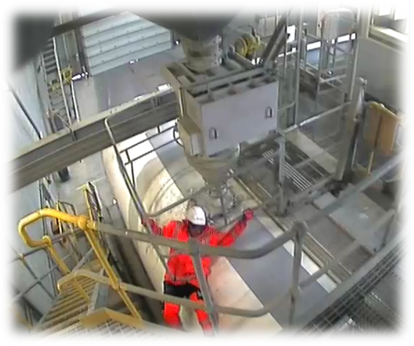
The subsequent investigation identified that the gap between the base of the protective loading cage and the top of the tanker did not provide adequate fall protection for the drivers.
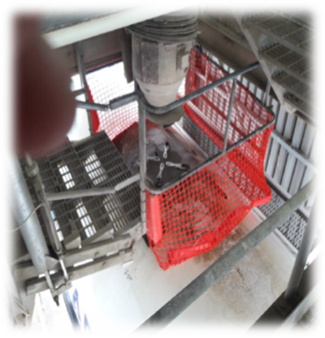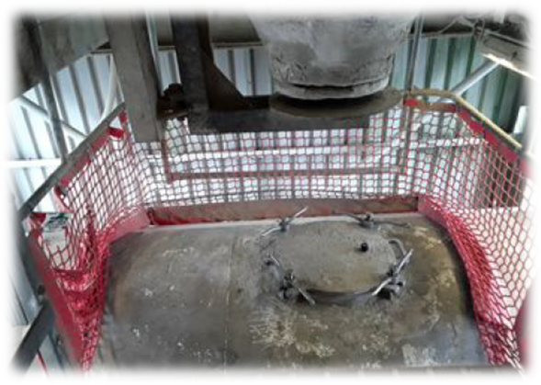

MANAGEMENT OF PROCESS
As a result, an action was taken for the Logistics engineering team to review the process and investigate potential improvements to assist all drivers in ensuring protection was improved to eliminate the risk of a fall from the top of the tanker

- A national review of all loading heads identified a similar risk due to varying tanker and loading head protective cage configurations and dimensions.
- The employed and contracted drivers were engaged in potential solutions taking account of varying vehicle size, dimensions and orientations with feedback collated acting as an input to the solution process. This information gathering was conducted both in safety forums and on-site at the loading points.
- The Logistics management team gave the remit to the engineering team to design, develop and implement with the required resources and budget allocated to fully support the solution
- Following an internal review, the engineering team engaged with a specialist net manufacturer to produce a simple and cost effective ‘wrap’ around the cage
- A design was developed, manufactured and trialled:

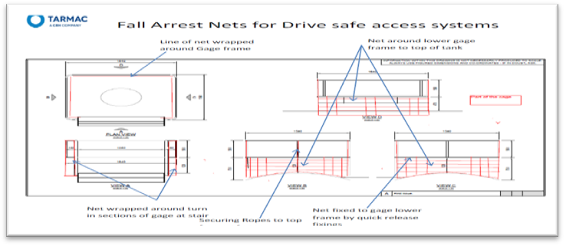

- Following several modifications, a final solution was agreed with the loading and transport teams resulting in the national implementation across all Tarmac Cement & Lime supply chain depot locations
- This resulted in an update to the local risk assessments with a tangible reduction in the risk to drivers

The roll out of the safety netting underpins the MPA Vision Zero shared values demonstrating visible, improved safety controls achieved through positive engagement and a high quality, auditable, tested implementation

BENEFITS
The roll out of the project on a national scale has helped to ensure the safety of not just Tarmac drivers but any customer collect or external haulier driver when loading at a Tarmac site.

Since implementation we have not had a related incident.

In keeping with the Fatal 6, the safe management of working at height specifically for delivery drivers has therefore improved by being better protected when undertaking out a daily and routine loading task.
INNOVATION
The final implementation has proven to be an innovative solution designed and developed between the logistics engineering team and an external manufacturer.

Furthermore, the innovation did not stop at the first design. Based on initial driver feedback there was a need to update the design to make this more user friendly for the drivers and eliminate an issue introduced by the first design, which was the tanker hatch lids ‘catching’ on the netting itself. As a result the latest design incorporates a section that enables the driver to place the tanker lid against, which will not impact their handling of the lid.
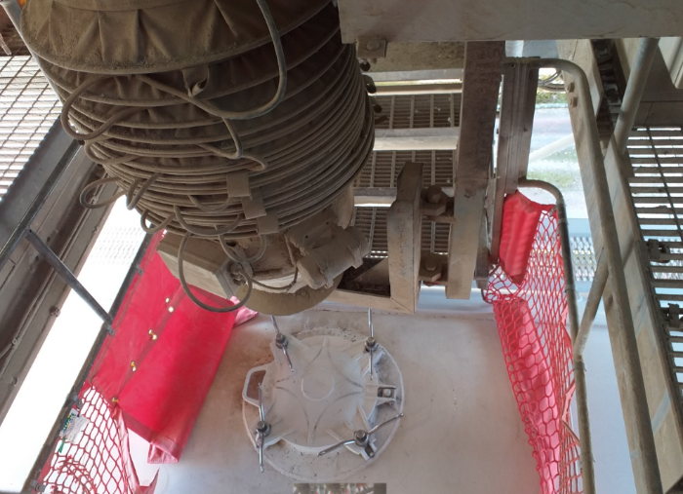

An additional design challenge that required an innovative solution was the annual testing process to measure and ensure the ongoing integrity of the netting. Therefore, an additional section has been added which can be removed and tested as part of a statutory inspection process to that any deterioration in the materials over time is checked and effectively managed.

DEVELOPMENT & TRANSFERABILITY
This solution can be simply transferred to any other bulk powder loading point.

It is standard within this industry for the driver to have to manually operate the lid and therefore the loading head set up across bulk powder loading points are similar in nature. Therefore, this can be applied across other companies and at sites outside of Tarmac.

Regarding further development, Tarmac are also trialling a tanker at our Northfleet depot fitted with an automated opening hatch lid. This will eliminate all working at height for the driver as there will be no requirement to access the top of the tanker:
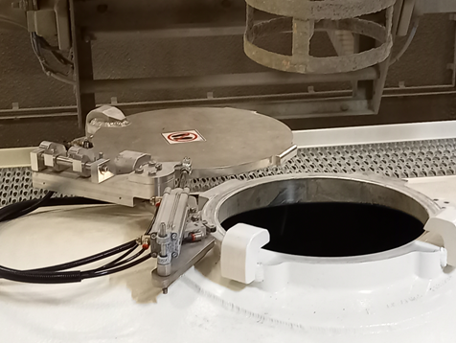

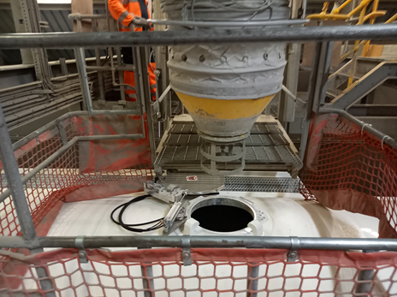
This will not remove the need for the netting solution as it is unlikely that all our Transport partners and customer collections will be in a position to install this automated enhancement.
NB if document has embedded images try and include these
If other documents provided say additional information available.

