Topic entry (tick boxes that are applicable) 1 X 2 3 4 5 6 7 8
Entry number (MPA Ref) | 22007
Title of Entry | LOTOTO demonstration training aid
Name of Company | Lhoist
Location | Whitwell Works
Video (if yes, please include URL for video) | No
Other resource (if yes, please include description)
Fatal Theme (tick boxes that are applicable) 1 X 2 3 4 5 6
BACKGROUND
The Electrical department wanted to create a training tool to allow relevant employees the opportunity to practice fault finding on invertors, motors, local isolators and control circuits. The electrical apprentice began developing a mock electrical motor circuit display with an invertor, this allowed a practical method to fault find which proved very useful when out in the field.

The training board later evolved into a LOTOTO training aid with the addition of isolators, pull cords etc. This has now become a part of the site training tool for LOTOTO.

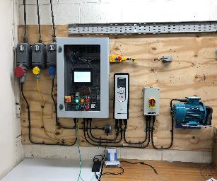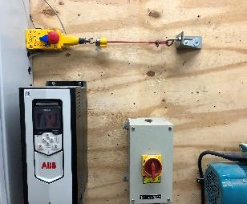

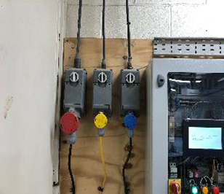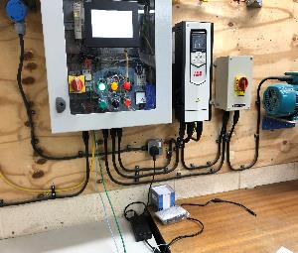
MANAGEMENT OF PROCESS
Spare electrical equipment was used to develop the training board in such a way to mimic electrical motor circuits out on site. This became a project that the electrical apprentice used for their college course work to demonstrate working competency of installing and working with electrical circuits.

As part of the development of this course work, the department decided to involve all electrical technicians to give greater awareness of emergency stop functions on machinery/conveyors etc. De-energising features on the board were designed to demonstrate how circuits work when they appear to be in full working order but are faulty. This allows the trainee to apply the LOTOTO method.

Once the training board was completed it was tested from the incoming 110 & 415 supplies all the through the panel to the motor.

The electrical supervisor supported the project by giving guidance, time, and mentorship to progress to completion.

BENEFITS
The training board is now an extension of the site isolation policy and demonstrated to all employees. All new employees who have never experienced the theory of electrical circuits and isolation methods now get the chance to have first-hand experience of how LOTOTO works within a controlled environment, without having to go onto site.

The emergency stop features can be altered to give the impression that isolation has been achieved when it has not, this demonstrates the importance of Lock Out Try Out.

Giving employees prior awareness to the hazards and dangers of not isolating correctly creates a safer environment.

INNOVATION
The site now has the ability to be demonstrate the LOTOTO method to all stake holders in a controlled environment, giving a greater understanding of the hazards.

DEVELOPMENT & TRANSFERABILITY
The training board can be recreated in any environment to suit the business needs in reducing risk and enhancing LOTOTO awareness.
NB if document has embedded images try and include these
If other documents provided say additional information available.

