Topic entry (tick boxes that are applicable) 1 X 2 3 4 5 6 7 8
Entry number (MPA Ref) | 22046
Title of Entry | Safe removal of stop ends
Name of Company | Forterra
Location | Hoveringham
Video (if yes, please include URL for video) | No
Other resource (if yes, please include description)
Fatal Theme (tick boxes that are applicable) 1 2 3 X 4 5 6
BACKGROUND
Historically, as part of the casting process for our beam production, in several of our shops the removal of the stop ends required the operator to stand on top of the bed and manually push the stop ends out. This process is referred to as “pogoing”. Whilst the bed itself is a stable working platform, it offered no edge protection, therefore resulting in a potential for an operative to fall from height. This was also one of the most manual processes in the department and very demanding physically especially in the hotter months of the year.
The requirement to eliminate the need to work at height is one of the Fatal 6.
Whilst this process had not resulted in any accidents being reported, it had been raised via hazard spots, near hits and was of focus in the Building Safety Together meetings.
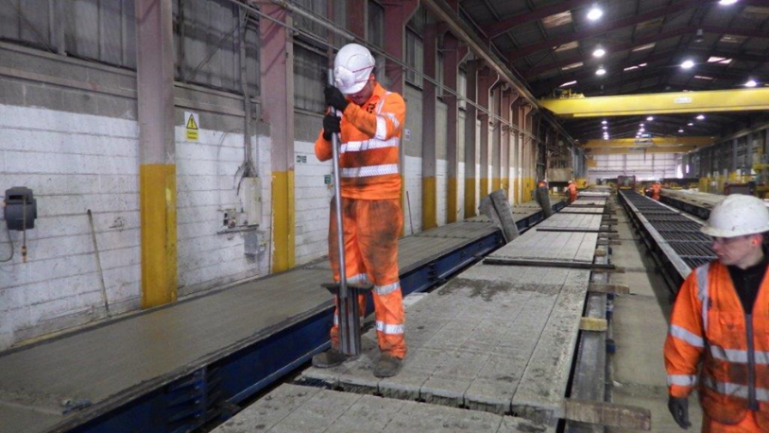
Initially, the stop ends were a two-part configuration (Block and Top) which would be placed in the mould, the block would hold the wires in the correct wire pattern within the mould. Once in place and wires inserted correctly, a top component would be inserted with the purpose of stopping concrete pouring into the block when the moulds were being cast. This would make it harder to extract the beams from the mould and removing the blocks later using the pogo method. These combined components and wires would then be cast over once all in place. Once the concrete had cured, the tops would be removed first, the whole beams would be extracted from the mould using a machine and placed wooden bearers. This would position the beams high enough to carry out the pogo process of forcefully pushing out the remaining body wedged between the concrete with a specially fabricated tool shaped like a pogo. There could easily be between 150 – 250 bodies to be pogoed out per bed (depending on the department or product type) with upto 6-7 beds per day. The bodies would need to be pushed all the way out of the concrete and all flashing knocked off as this could create implications for other processes further down the line.
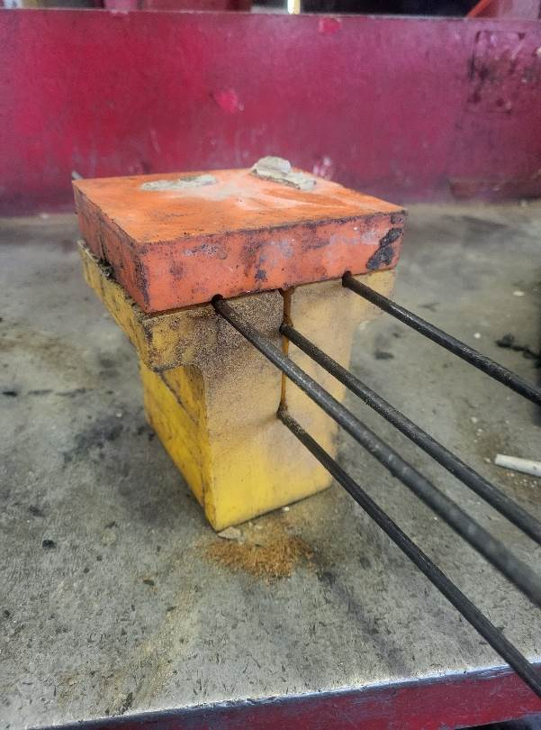
Old Type example Body and top

Top

Body
MANAGEMENT OF PROCESS
To improve this process, there was a need to redesign both the stop ends and the method of removal.

The stop ends are now one complete fully bodied unit that are fitted from the top over the wires once the bed has been stressed. There are no removal straps and the whole unit is cast over. Via the addition of a key that fits in the top of the stop end and the introduction of a hydraulic unit, this now allows the stop end to be pulled free from the mould / product once the concrete has cured enough.

The hydraulic lifting system had been purchased previously for an alternative task; however, this was never utilised as the original concept of its use was not sufficient. This piece of equipment was adapted to be used within this process.

This has now eliminated the need for an operative to be positioned on top of the bed working at height and manually removing / forcing the stop ends out of the concrete removing all manual aspects of the process.

This design and concept reflect many of the MPA Vision Zero Values: -

- Empowerment – that site has felt empowered to consider alternative uses for redundant pieces of equipment.
- Leadership – that the Management have fully supported and encouraged this
- Zero Tolerance – the site has been driven with continuous improvement for this working practice as part of the Fatal 6
- High Quality Implementation – the design and concept have gone through many considerations to ensure success to a high standard
- Collaboration and sharing – with the immediate team undertaking the process being involved from the outset.

BENEFITS
The benefits of this change are firstly the elimination of the need for an operative to climb onto a bed and work at height. It has also removed the physical aspect of pushing out the stop ends. The removal of stop ends is now automated and therefore this has improved the amount of time taken to remove these.

Other benefits of this change have eliminated the physical aspect of the bed cleaning process. This has enabled us to utilise this manpower in other areas of the department, which has created a more positive atmosphere within the team.

It’s easier to extract the beams from the mould with the product lifter, the whole block is removed now prior to the process being undertaken exposing all the wires to lift from with the hooks of the lifter, the old-style unit made it harder to locate the hook of the product lifter into the block as there was only a small hole.

Removal of working at height is part of the Fatal 6.

This has been seen as a positive improvement within the process and was welcomed by the operatives.
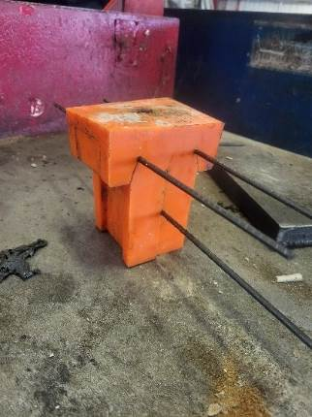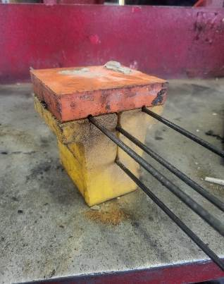

New Example full bodied unit. 3 wires
Example old Type Body and top. 4 Wires

Using this new type stop end (as you can see from the picture) has enabled us to remove a wire without effecting the structural integrity of the product. We used 4 wires with the old-style block, the 4th wire was only for helping to remove the product from the mould due to the design of the stop end and nothing to do with the strength of the beam. With the new full-bodied stop end we only use 3 wires as we can still remove the beams with the remaining middle wire. This reduction of wire has helped the site save over £400.000 for this shop alone with additional savings from other departments to come. This has helped the business counteract the price increases of steel within the industry while still making a saving to the business.
INNOVATION
Before the alterations were made, the redundant piece of equipment had been sat in a corner gathering dust and was a waste of more than £20,000. Utilising and modifying this machine with a new design and use concept, this is a clear case of using innovation and has only benefitted the department going forward.

This is also a unique way of resolving this issue and has allowed a clear enhancement to this working practice.

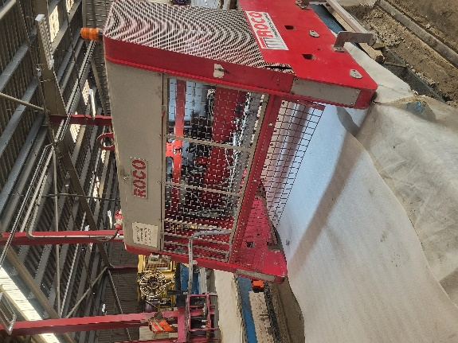
New process in operation
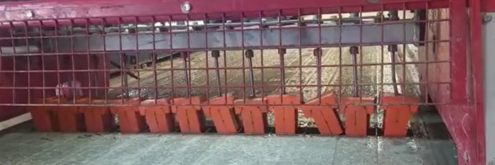
DEVELOPMENT & TRANSFERABILITY
Now that this has been successfully implemented within this shop, the principle can be utilised in other areas of the Hoveringham site.
NB if document has embedded images try and include these
If other documents provided say additional information available.

