

Quarries National Joint Advisory Committee (QNJAC)

Occupational Health

Information Sheet 9

October 2012

Snake Bites

This information sheet has been developed by the Quarries National Joint Advisory Committee (QNJAC) to help quarry operators, contractors, managers and others make health and safety improvements in the quarry industry. This guidance represents good practice which may go further than the minimum you need to do to comply with the law

Approved by the Quarries National Joint Advisory Committee (QNJAC)

(Version 1: 24 October 2012)

Target Zero Occupational Health Information Sheet No 9: Snake Bites

Legal Requirements:

Management of Health & Safety at Work Regulations 1999
These require a risk assessment to be carried out for all work activities. If there are snakes on your site then this must be recorded in the assessment and the assessment must include measures to control the significant risks that are identified.

The Control of Substances Hazardous to Health Regulations 2002 (COSHH)
These require that risks of infection and allergy be assessed and adequately controlled.

Quarry Regulations 1999
These require the production of a new document demonstrating that the risks to which persons are exposed have been assessed in accordance with regulation 3 of the Management Regulations 1999.
Why you should read this guidance?

Adders are the only poisonous snake we have in the UK.

They hibernate in the winter, so most encounters are likely to occur between March and September.
They are found in wild places such as heathland, downs, moorland and wooded rides.
They are not very common and even in ‘adder territory’ the chance of an encounter is slim.
Although adders are poisonous, they are shy and non-aggressive. They will usually try to avoid people. They sense the vibration of someone approaching, or see their shadow and will often scuttle away.

Adders are cold blooded so often bask in the sun. If you come across one basking, leave it alone and give it room and you should be OK.

Do not try to handle an adder. Most people are bitten whilst holding one.
Fatalities are rare, the last one in the UK was a child in 1975.

You are most a risk if you are bitten after the winter hibernation when the fangs have a full charge of venom, thereafter the dose will be smaller as it uses the venom to catch its prey.

Even if bitten, the adder can bite without releasing venom, or only releasing a small amount.

How do you know it is an adder?

Adders can be variable in colour but typically the background colour differs in males and females. Males towards a grey, whitish, occasionally yellowish colour. The contrast with the black markings can make them appear almost silver. The females tend to be brownish with considerable variation of shade and occasional hints of red and yellow, although in the latter case always a much darker shade than the males.

Both sexes are similarly marked. Typically these markings are very pronounced and extremely easy to identify, consisting of a heavy dark zigzag pattern down the back with dark spots in rows on the flanks. At the back of the head there is a heavy ‘V’ or ‘X’ shaped marking and a dark band running from behind each eye. The young are coloured and marked much like adult females.
Although adders are rather stocky snakes they are not very big, seldom exceeding 60cms in length, the males being slightly shorter. The head shape is notably different from other British snakes being rather broad and angular with an upturned snout.

The eyes are large and tend to be reddish in colour with a vertical pupil, again a feature unique to this species in this country.

The back pattern can vary in some individuals. With these variations there are occasional individuals that are not readily identifiable.

Female Adder

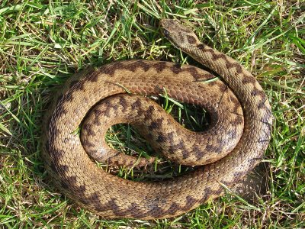

Male Adder

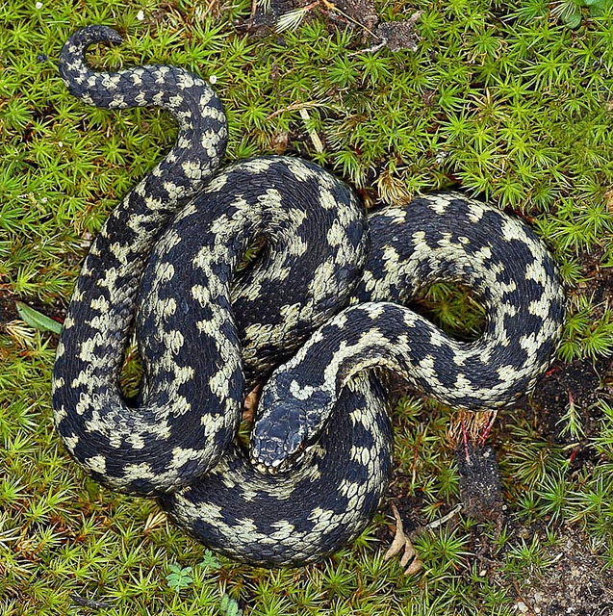

Payback/Benefits to the business:

Benefits to the business – a tool for risk management of individuals to protect their health and safety and others who may be affected.

What guidance is currently available?

- http://www.nhs.uk/conditions/Bites-snake/Pages/Introduction.aspx
- http://www.forestry.gov.uk/forestry/adder

Good practice currently available:

How to avoid snake bites:

- Wear long boots and trousers.
- Make a noise (vibrations in the surroundings by beating things or branch on the ground three to five paces ahead.
- Avoid going out in snake areas in the darkness.
- If you see a snake you should stand completely still. It will instinctively prefer to go away.
- Do not put your hands down into holes, dark cavities or cracks in rocks, even if something falls down it. To reclaim anything, you can attempt to fish it out with a stick, standing well away from the hole.
- Do not pick up a dead snake you can still be bitten.

What to do if you are bitten:

- Do not panic! Keep the affected area immobilised and get to a hospital for treatment. You may get numbness in the area of the bite, and can get nausea and dizziness. Driving is not a good idea because of this. Get medical attention even if you feel fine. People can get unforeseen complications from the bacteria in the wound rather than from the venom itself.
- Do not try to suck out the venom or cut the flesh in any way as this can cause further complications.
- Do not use bandages or tourniquets as these can cause permanent damage or loss of limb.
- The area may become swollen – this is normal.
- The A & E doctor will assess the bite and recommend treatment.

Whilst waiting to be seen by the doctor:

- DO NOT EAT OR DRINK ANYTHING
- DO NOT ENGAGE IN PHYSICAL OR STRENUOUS ACTIVITY
- DO NOT TRY TO SUCK OUT THE VENOM
- DO NOT TRY TO CUT OR INCISE THE BITE MARKS WITH A BLADE
- DO NOT DRINK ALCOHOL
- DO NOT APPLY HOT OR COLD PACKS
- DO NOT TRY TO KILL, BAG OR BRING IN THE OFFENDING SNAKE
- DO NOT APPLY TOURNIQUETS OF ANY KIND

Training/Toolbox Talks:

The content of this guidance could be used as the basis of a simple Toolbox Talk.

Key Performance Indicators to Consider:

Record areas where adders are seen on site.

This information sheet has been produced by the QNJAC Target Zero Occupational Health Working Group. It has been approved by the Quarries National Joint Advisory Committee (v1 date 24/10/2012).

