Quarries National Joint Advisory Committee (QNJAC)

Geotechnics, Face & Stockpile Operations

Information Sheet 2

March 2011

Guidance on Excavation and Tip Rules
in Quarries

Approved by the Quarries National Joint Advisory Committee (QNJAC)
(Version 1: 23 March 2011)



















Kaolin and Ball Clay Association (UK)








QNJAC Information Sheet 2 

GUIDANCE ON EXCAVATION AND TIP RULES

PREFACE

The guidance in this Information Sheet has been endorsed by the Quarries National Joint Advisory Committee (QNJAC). Following this guidance is not compulsory and you are free to take other action. Health and Safety Inspectors seek to secure compliance with the law and may refer to the contents of this Information Sheet as illustrating good practice

1 INTRODUCTION

  - The Quarries Regulations 1999, together with the Approved Code of Practice and Guidance (ACOP) make a number of references to the requirement for Excavations and Tip Rules (E&TR), including the following, as stated in Regulation 31.

The operator shall ensure that suitable and sufficient rules (known in these Regulations as the ‘excavations and tips rules’) are made to ensure the safe construction and operation of excavations and tips and such rules shall, in particular, specify the following matters:

- The manner in which such activities are to be carried out.
- The nature and extent of supervision of such activities.
- The precautions to be taken during such activities to ensure the health and safety of any person and the safety and stability of the excavation or tip.

  - It should be noted that the E&TR need to cover all features and operations regardless of their size. The amount of detail in the E&TR should be in proportion to the risk posed. Examples of the sort of information that should be included (this is not an exhaustive list):-

- Geotechnical Assessment
- Quarry Design
- Plant design and type
- Geotechnical appraisals
- Risk Assessments
- Standard Operating Procedures (SOP’s)

  - This E&TR should be used to communicate information in a simple relevant and understandable manner to any person who needs to know. The aim should be that all relevant activities are co-ordinated in a safe, practical manner.

  - The duty to produce the E&TR rules lies with the Quarry Operator, but may be delegated to an Appointed Competent Person. It is considered good practice for them to be produced in conjunction with the relevant personnel involved in the operation and design of the site.

- FORMAT OF THE RULES

  - The E&TR need to be designed in such a way that they can be communicated and explained so they are understood by all relevant people (in accordance with Regulation 10). For example, the following job roles, either employee or contractors, should be considered.

- All mobile plant operators
- Drilling and Blasting personnel
- Management
- Visitors
- Anyone else who may be affected

  - Depending on size and complexity of the site/contract, consideration should be made to the format of the E&TR. An option is to have an “Umbrella Document”, underneath which will site a series of documents, such as schemes, plans and SOP’s.

  - A SOP should be referenced under the “Umbrella Document”, but only issued to personnel authorised by the relevant SOP’s, thereby tailoring the rules to the person(s) involved and the tasks to be undertaken. This would make the rules directly relevant to those who need to comply with them and therefore be readily understood and followed. An example of a SOP document is given in Appendix 1.

- CONTENTS OF THE RULES

  - The Quarries Regulations 1999 Approved Code of Practice is specific in Regulation 31 regarding Excavation and Tip Rules. However, a check list of considerations is provided in Appendix 2 of this note.

  - A quarry may be a complex site, made up of numerous different E&T features, each with its own design. Therefore, the content of the E&TR needs to include the key elements of these designs to ensure safe construction, operation and maintenance of those features. It may be useful to utilise plans and diagrams in lieu of words.

  - The first part of the E&TR should clearly define:

- What and who the rules apply to.
- What other documents need to be read in conjunction with the rules.
- Who has responsibility for maintaining those rules?
- What are the mechanisms for their regular review and update?

  - The E&TR should provide an overview of how the quarry is to be developed, including the sequence of excavation, tipping operations, tip strategy, method of excavation, processing and storage of stockpiled materials. This can, in part, be achieved by reference to accompanying plans. Consideration should be given to:

- Design.
- Preparation (Overburden Stripping).
- Operation (including utilisation of machinery).
- Inspection, recording and reporting regime.
- Record of Substances tipped.
- Maintenance.
- Closure, decommissioning, suspending operations, final face location and condition.
- Restoration.
- Mines Waste Directive compliance.

- CREATION, REVIEW AND ISSUE

  - In order to ensure that the E&TR remain relevant to the way the quarry operates, the rules should be reviewed on a regular basis, ideally at least annually. If a significant change to notifiable features occurs, then, under Regulations 31, 32, 33 and 34, a Geotechnical specialist must review the E&TR rules. Some examples of change to notifiable features are list below and covered by Information Sheet 3 – Guidance on Managing Change to the Excavation or Tip.

- Changes in operating machinery.
- Quarry design.
- Geological ground conditions.
- Location of infrastructure.
- Restarting after dormancy.
- Suspension and activation of quarry operations.

  - It is a requirement to ensure arrangements are in place to involve those who work at the quarry to provide feedback and suggestions as to how the E&TR can be improved or where they are failing.

Appendix 1: Example of Standard Operating Procedure
Cleaning out a silt lagoon with an excavator

Distance from crest
to toe table.
(Minimum distances)
h d
5m 7.5m
6m 9.0m
7m 10.5m
8m 12.0m
9m 13.5m
10m 15.0m
The excavator machine will remain on stable ground at all times
Edge of lagoon clearly marked
Potentially unstable ground
Haul routes located beyond working area
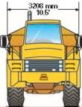

Allowance for potential break back
3m
1 in1.5 = 35°
NOT TO SCALE
Escape route

Tracks facing the excavation to allow rapid exit
Silt stockpiles for later removal.
Placement should allow a rapid exit by the machine.

d
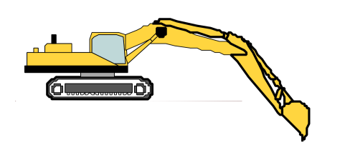
Distance from
Crest to toe = 1.5 x h
h = vertical height of face from toe to crest

The main risks when cleaning out a silt lagoon are created either by undercutting and making unstable the embankment, particularly below water or by a machine driving onto soft ground that cannot support the machines weight.
Silt lagoons can be deceptive, they form a crust which appears stable, but the silt remains soft beneath.
To manage this risk the guidance below will be followed:-

Pre Commencement Planning
- A risk assessment will be carried out to identify the appropriate machinery
Inspection and monitoring
- Regular inspections of the operational area will be carried out by the Quarry Manager or appointed competent person.
- The inspections will be at a frequency that is appropriate for the operation, but no less than daily
- The operator working the machine will constantly monitor the crest of the lagoon for sign of slumping, cracking or instability.
- Upon observing any signs of instability, all work will be suspended; personnel and machinery removed and access prohibited. The operator will inform management and geotechnical advice will be sought if required.
Method
- Work in accordance with the diagram above
- Access onto the silt is not permitted unless capped and stabilised and authorised by the Unit Manager.
- Care will be taken to only remove silt as planned and not excavate the lagoon retaining structure.
- The edge of the silt pond will be clearly demarcated at all times, ideally by barriers such as a bund.
- The excavator will be as far from the lagoon edge as operationally possible and will be capable of obtaining the necessary depth of dig whilst maintaining the required stand-off
- The excavator’s tracks will be perpendicular to the lagoon edge such that a safe, rapid exit from the area can be made if slope instability develops.
- The excavated silt will be cast as far away from the crest of the lagoon as possible so as to prevent loading of the crest which could cause failure. The placement of silt must not block the safe exit route of the machine.
- When not in use all machinery will be parked in a safe location away from the waters edge.
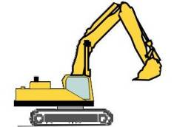
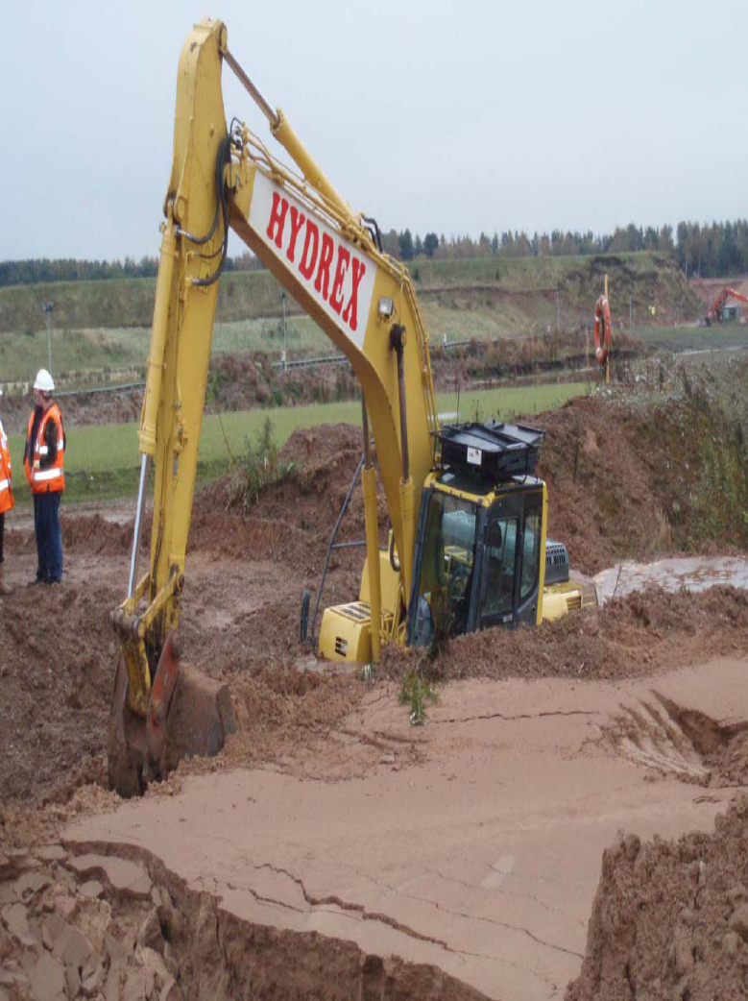
A firm crust can form on top of the silt, but remain soft underneath.

Machinery must not track on to silt
✗

✓✗

Edge of lagoon clearly marked

Appendix 2: Guidance Checklist for E&T Rules Content
Introduction

- What is the purpose of the rules?
- Who do the rules apply to?
- What other documents need to be read in conjunction with the rules?
- Who has responsibility for maintaining those rules?
- What are the mechanisms for their upkeep?

Quarry Overview (May be covered in part by accompanying plan(s))

- Sequence of development.
- Reference to plan/documents that help show / describe the detailed phasing of the site.
- Extraction strategy.
- Solid waste/tip strategy.
- Liquid waste/tip strategy.
- Storage of stockpiled materials.
- Haul route strategy.

Excavation

- Method of extraction.
- Reference to machine selection documents (If not detailed in E&T Rules).
- Design Criteria.
- Reference to specific design documents (If not detailed in E&T Rules).
Angle of face(s).
Face height(s).
Bench widths.
Stand offs.
Rock fall protection measures (catch bunds).
Edge protection.
- Supervision.
- Appointed responsible people.
- Duties.
- Frequency of inspections.
- Notification of defects.
- Stockpiles.
- Design Criteria.
- Reference to specific design documents (if not detailed in E&T Rules).

Solid Tips

- Design Criteria.
- Reference to specific design documents (if not detailed in E&T Rules).
- Supervision.
- Appointed responsible people.
- Duties.
- Frequency of inspections.
- Notification of defects.

Liquid Tips

- Design Criteria.
- Reference to specific design documents (if not detailed in E&T Rules).
- Supervision.
- Appointed responsible people.
- Duties.
- Frequency of inspections.
- Notification of defects.

Haul Routes

- Design Criteria.
- Reference to specific design documents (if not detailed in E&T Rules).
- Supervision.
- Appointed responsible people.
- Duties.
- Frequency of inspections.
- Notification of defects.

Controlled Document Details

- Version.
- Approved By and Date.
- Issued By and Date.

