Occupational Health

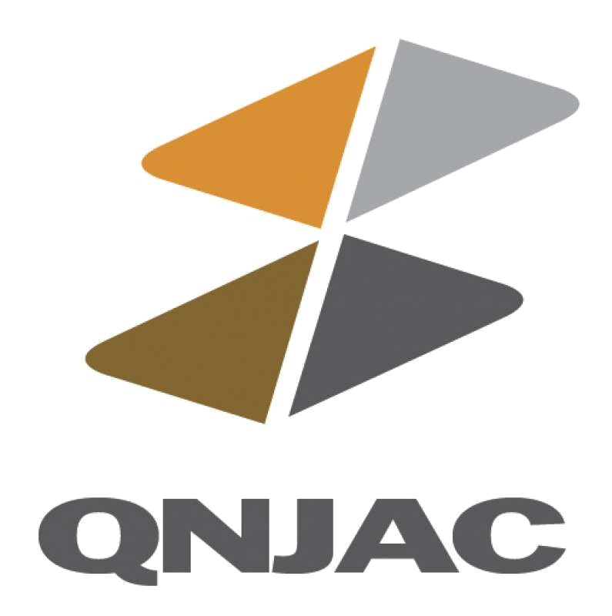

Quarries National Joint Advisory Committee (QNJAC)

Occupational Health

Information Sheet 4

January 2013

Legionella

This information sheet has been developed by the Quarries National Joint Advisory Committee (QNJAC) to help quarry operators, contractors, managers and others make health and safety improvements in the quarry industry. This guidance represents good practice, which may go further than the minimum you need to do to comply with the law

Approved by the Quarries National Joint Advisory Committee (QNJAC)
(Version 1: 25 January 2013)

Control of Legionellosis Risk in Quarries & Associated Mineral Activities

Legal Requirements:
Management of Health & Safety at Work Regulations 1999.
These Regulations require a risk assessment to be carried out for all work activities.

The Control of Substances Hazardous to Health Regulations 2002 (as amended) (COSHH).
Legionella is a bacterial agent and falls within the scope of these Regulations. The Approved Code of Practice (ACOP) & guidance titled ‘Legionnaires’ disease’, The control of legionella bacteria in water systems, ref: L8 is a useful source of reference

Quarries Regulations 1999.
These Regulations require the production of a document demonstrating that the risks to which persons are exposed have been assessed in accordance with regulation 3 of the Management Regulations 1999

Why you should read this guidance?

This document is intended to assist the surface minerals industry in reducing the risk of ill health from exposure to legionella bacteria in water systems and in meeting its legal requirements in relation to the control of legionella from mineral processing operations as part of a water hygiene programme.

Legionella

Legionella bacteria are aquatic organisms and are common throughout nature. They thrive in warm, stagnant water where there is a good supply of nutrients. The organisms do not multiply at temperatures below 20°C and are killed above 60°C. The presence of biofilms/algae, sediment, scale and organic matter in the water harbours and provides favourable conditions for growth.

Inhaling contaminated aerosol or spay containing legionella bacteria can lead to a spectrum of infections ranging from short, febrile illnesses to serious pneumonia, known collectively as ‘legionellosis’. Cases of pneumonia are classified as Legionnaires’ Disease, which has a fatality rate of approximately 10 -15%.

Not everyone exposed to the organism will go on to develop disease, but those with underlying health problems or respiratory disease are more susceptible along with males, the over 45’s, smokers and heavy drinkers. It is not just those persons on site that have to be considered, but also those off site from drift of the aerosol or spray.

There are approximately 250 diagnosed cases of Legionnaires’ Disease reported in the UK each year, but it is recognised it is under reported. Cases have generally been associated with cooling towers, hot and cold water systems, spa baths and humidifiers, but any system that provides favourable conditions for growth and has the potential to generate contaminated aerosol poses a risk of exposure to legionella bacteria. These are classed as ‘other risk systems’ in L8.

What you need to do

As most mineral operations involve either wet dust suppression systems or processes involving the use of water an assessment will need to be carried out at these sites. Hot and cold water services found in offices and welfare blocks will also need to be considered, especially as showers are a common feature. However, it is considered that sufficient existing guidance can be found in the sources of information detailed in the Further Advice section below. For this reason hot & cold water services are outside the scope of this guidance.

At quarries, the Quarry Operator will need to ensure the person carrying out the assessment is competent and this is also a requirement of the COSHH ACOP on the employer for other premises.

The following details the necessary control framework

- Identify and assess sources of risk
- Prepare a scheme for preventing or controlling the risk
- Implement and manage the scheme
- Keep records and check that what has been done is effective
- Appoint a responsible person

The written scheme is an important document. It will evolve from the assessment process and should include the following items:
- A plan or schematic of any water systems and processes in use
- How the systems shall be operated safely
- What precautions are to be taken
- Any checks or inspections to be completed on the system
- What actions to be taken if there are any failures in the scheme

Sources of risk at mineral activities

There is no evidence to suggest that quarrying presents a heightened risk compared to other industries and there is no data that confirms quarry premises as sources of disease outbreaks. However, large quantities of water are used in quarries for dust suppression and process reasons
Quarry water systems typically use non-mains supply sourced from bore holes and/or lagoons. It is usually recycled and is prone to contamination by process dust and environmental matter such as soil and plant material. Stored water in tanks or pipes may be stagnant for periods and in warm weather the temperature may rise above 20°C.

Therefore the risk factors include:
- Water
- Growth temperature range of 20ºC to 45ºC
- Nutrients – biofilm /algae, rust and scale
- Aerosol/spray/mist

The following water systems in the minerals industry are likely to include the above risk factors , however this list is not exhaustive:

- Water being sprayed onto extracted material as it is excavated or deposited into dumpers by the use of fogging cannons/directional misting units
- Dust wet suppression of product at transfer and discharge points
- Water being sprayed onto roads for wet suppression of dust using water bowsers, tractor vacuum tankers and fixed sprays
- Use of hoses to clean areas of hardstanding around processing plant & site buildings
- Water spray from vehicle/ wheel washers
- Use of water as part of the production process e.g. barrel washers, wet scrubbers, cooling of cutting blades on saws
- Plant creating water curtains for dust control e.g. for dimensional stone cutting & processing
- Emergency showers e.g. at asphalt plants

Risk Control
Suggested control Strategies

The appropriate control strategy will be derived from the assessment and should be based on limiting the conditions that present favourable conditions for growth. By applying simple, low cost measures the potential for growth and thereby the potential for exposure can be significantly reduced and appropriately controlled.

Temperature control
Temperatures in the range 20 - 45°C favour growth, so avoiding storage and use of water in this range is essential and likely to be a primary control. In the UK, where ambient water temperatures rarely rise above 20°C, it is only during extended hot spells in the summer months when this is likely to occur or where the process introduces sources of heat.

The smaller the volume of water, the more rapidly the temperature will rise: distribution of water from large storage areas (such as lagoons) into smaller volume ponds, tanks and bowsers for local use, facilitates temperature increase especially if they are located where they are subject to solar gain. Insulating and/or shading water storage vessels, pipes & hoses may help reduce this. The colour of the surface of vessel or enclosure may also have a significant effect.

Consideration should be given to water systems subject to other sources of heat gain. For example the use of proprietary wheel/vehicle wash units, which have internal water tanks in close proximity to electrical plant may act as a heat source and lead to elevated water temperatures.

Legionella bacteria are rapidly killed above 60°C, but using thermal disinfection as a control option is unlikely to be a practical solution in mineral processing..

Where temperature is a control, the following measures should be considered:

- Implement a system of temperature monitoring for all stored water. An initial suggested frequency of temperature monitoring would be monthly between October and March, weekly between April and August, up to daily during hot spells. Temperature checks should be made when temperatures are likely to be at their highest.
For systems, where ambient water temperature peak within the low twenties Celsius for more than 2 days, additional measures should be considered. For example, draining warmed water from the system and either, leaving it empty if not in use or replacing it with cool water. If a control is to drain the system, care should be taken to ensure the entire system is drained including all low points.
Alternatively chemical treatment of water system may be another option. If chemical treatment is required specialist advice should be sought. Regular chemical treatment of stored water is unlikely to be necessary throughout the year.

Minimising sources of nutrients
Contamination of the water may arise from a number of sources including scale build-up, deposition of process solids and environmental contaminants such as leaves, insects and other debris. Open topped vessels may also be subject to contamination including vermin and their droppings. Dirt and debris in the water helps support bacterial and algal growth, leading to the development of biofilms, which are known to harbour legionella bacteria.

Corrosion of the vessel and internal coatings may also support growth by providing a surface to which the organisms adheres. Rusting of metal storage vessels provides a source of iron, which is an essential nutrient for many microbes.

The following should be considered to limit the build up of contamination in the water:

- Prevent contamination by leaves, soil and vermin by ensuring water storage vessels are lidded
- Implementing a system of inspection of storage vessels to check for silting up, development of biofilm/plant growth or signs of corrosion
- Drain and clean where there is evidence of deposits, algal/plant growth and biofilm
- Regular maintenance of storage vessels to limit corrosion of internal surfaces
- Check spray nozzles on wheel washers and sprinklers for evidence of scale build-up and clean where necessary

Preventing stagnation
Standing water increases the risk of microbial growth and is prone to heat gain. Water system capacities, in particular storage tanks should be matched to the system demand to ensure adequate flow.
.
Microbiological analysis
Where the measures in the written scheme are being applied and water quality is satisfactory (e.g. temperatures are consistently below 20C and water is stored in a clean condition) it should not be necessary to undertake routine microbiological monitoring. However, if temperature monitoring indicates a problem (as described earlier), microbiological analysis may provide useful information on the control within the system and to what additional measures may be required. This may include proprietary 'dip slides', which give an indication of the overall microbiological control and may be undertaken locally without the need for a laboratory. Alternatively, the water may be analysed specifically for legionella bacteria, but this requires the services of an accredited laboratory. Interpretation of microbiological analysis is frequently difficult and should only be carried out by a suitably experienced person. The recommendation is therefore to ensure that the steps set out in the written scheme are followed consistently and only consider microbiological monitoring if problems arise. Competent advice should be sought when considering microbiological testing

External Emergency showers
Appropriate controls for emergency showers is a common question and these systems have the potential to be missed, when considering external process water and internal hot and cold water systems.

Emergency shower roses should be dismantled, de-scaled and disinfected on a quarterly basis. Header tanks should be annually checked for deposits, the tank should be enclosed with a close fitting lid and be insulated.

These systems should have a mains quality water feed and be flushed through and purged to drain monthly during the summer months, over and above pre-use checks. If the shower is not used weekly then it should be purged straight to drain by bypassing the shower head. Maintenance records will also need to be kept.

Appointments framework
This is likely to be different in large national companies to that of smaller companies. L8 ACOP requires a responsible person to be appointed for the control of legionella. In relation to lower risk systems associated with common quarry systems it is considered the existing management structure under the Quarries Regulations 1999 will identify this person. The quarry management may then appoint individuals to implement aspects of the written scheme. Competency can only be determined by the quarry operator or employer and will be dependant on the individual and the complexity of the water systems

Further Advice
Further advice on legionella control and the provision of training can be sourced from relevant trade associations such as the Legionella Control Association at http://www.legionella-conduct.co.uk

The Approved Code of Practice (ACOP) & guidance titled ‘Legionnaires’ disease’, The control of legionella bacteria in water systems, ref: L8, can be freely downloaded at http://www.hse.gov.uk/pubns/priced/l8.pdf . It not only provides the legal framework for the control of legionella but also useful information & guidance. However large parts of the document relate to very high risk systems such as cooling towers, and large scale hot and cold water services , such as those found in hospitals etc and not normally associated with the minerals industry.

Additional advice from HSE can be found at http://www.hse.gov.uk/legionnaires/index.htm

