No Smoking Day
14 March 2018

It's No Smoking Day on 14 March - the perfect time to quit smoking. For free support going #Smokefree, visit www.nhs.uk/smokefree
Quitting smoking is the best thing you'll ever do for your health, your family and your wallet! So, this No Smoking Day, join the millions who've already gone #Smokefree. Visit www.nhs.uk/smokefree

Everyone's different, which means the way you quit smoking needs to be your choice. It's all about working out what's right for you to increase your chances of quitting for good.

10 steps to stopping smoking

Stopping smoking isn't easy, but there are things you can do to improve your chances of success. Read our ten top tips:

- Pick a quit date
Choose a day that will be stress-free, and stick to it.

- Make a list
Write down all the reasons you want to quit. Keep the list handy and read it when the cravings start.

- Build a support network
Pair up with someone else who's looking to give up smoking and support each other.

- Remove any reminders
Before your quit date, get rid of ashtrays, lighters and matches, and any remaining cigarettes.

- Use stop smoking services
Contact your local NHS Stop Smoking Service for support from trained specialists.

- Try nicotine replacement therapy
Consider using nicotine replacement therapy, which can more than double your chances of stopping smoking.

- Start moving
Scientific studies have proven that exercise, as little as a five-minute walk or stretch, cuts the urge to smoke and may even help your brain produce anti-craving chemicals.

- Avoid trigger situations
Anticipate stressful or trigger situations. So, if you smoke after a meal, go for a short walk instead.

- Practise saying "no"
Don't be tempted by just one cigarette; it often leads to another.

- Treat yourself
Put away some, or all, of the money you would have spent on cigarettes and buy something special.

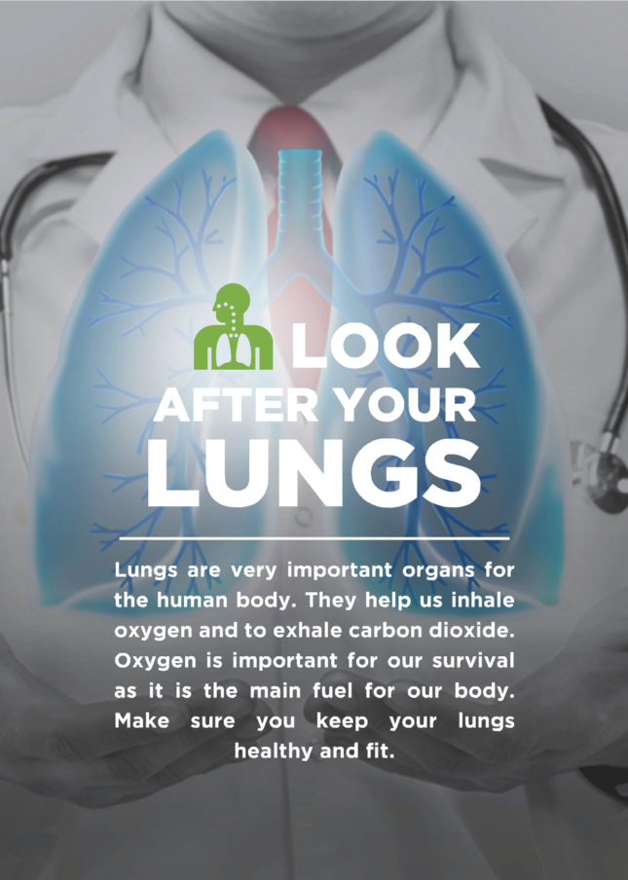
Quit smoking to live longer

Half of all long-term smokers die early from smoking-related diseases, including heart disease, lung cancer and chronic bronchitis.

Men who quit smoking by the age of 30 add 10 years to their life. People who kick the habit at 60 add three years to their life.

In other words, it's never too late to benefit from stopping. Being smoke-free not only adds years to your life but also greatly improves your chances of a disease-free, mobile, happier old age.

Please display the Health Essential Poster – Look After Your Lungs on notice boards and share with your teams.

Also take the opportunity to print off the CEMEX Workplace Wellbeing Calendar if you haven't already and track the wellbeing awareness days throughout the year.

