INTRODUCTION
PLEASE READ THE BRIEFING DOCUMENT BEFORE COMPLETING THIS FORM  It contains guidance on general criteria and the judging process.  It is important to check that your entry is being submitted under the most appropriate topic. Please see briefing note for guidance on your Topic selection, if you would like to discuss this please e-mail entries@mpahsawards.org  Please read the briefing document before completing this form. It contains guidance on general criteria and the judging process.  It is important to check that your entry is being submitted under the most appropriate topic.  To complete the forms, please download and save them on your system before adding content. Please read the notes before completing each section  Please note that word counts, suggested questions or tips are provided as a ‘typical’ guide only.  A box on the left side after the notes shows the maximum number of marks that a judge will allocate to each section.  PLEASE FEEL FREE TO SUPPLY ADDITIONAL INFORMATION  Images, video clips (e.g. taken on your mobile phone), documents, PowerPoints will help judges to evaluate and understand your entry.  WHEN YOU HAVE COMPLETED THE FORM PLEASE SAVE AS A WORD DOCUMENT AND E-MAIL TO entries@mpahsawards.org  Shortly AFTER you submit your Entry, MPA will supply you with a unique reference number to be used in future correspondence. | HELPFUL TIPS  MPA welcomes entries from companies of all sizes, it wants to hear about your health and safety ideas and be able to share these with others.  - Please keep within the recommended word counts for each section  - Consider using bullet points if it helps to minimise the use of long, detailed text  - Remember that images / graphics can help judges understand your entry  - Please focus on the key points and avoid the use of jargon  - If additional text is required, consider adding on a separate sheet.  - Remember to identify the key benefits and where possible quantify your achievements  - Ask someone else to review and help check the clarity of your entry  Please note that support and guidance can be provided by contacting entries@mpahsawards.org

TOPIC ENTRY
Please review the topic descriptions in the Briefing Note and consider under which topic your entry should be submitted. The short descriptions under each topic heading provide an indication of type of activities or initiatives that judges would expect to see submitted under this heading. Please select one topic from the table below and tick or add YES.

1. Safer production
2. Safer maintenance and housekeeping
3. Safer handling of inbound and outbound materials
4. Safer management of pedestrians and transport on site
5. Safer transport and logistics | YES
6. Safer operations at a contracting, construction or customer site
7. Safer through improvements in health and wellbeing (this could be company wide, a division, region or single site).
8. Safer together (this could be company wide, a division, region or single site).
Eurobitume Award and ‘The Fatal 6’ Award
Please note only MPA members are eligible to enter these 2 awards.
If you would like your entry to be considered for these awards simply tick or add YES to the relevant boxes in table below

Eurobitume Award is an additional award available to topic entries associated with bitumen, asphalt or paving/contracting.
‘The Fatal 6’ Award is for an entry that mitigates or eliminates one or more of ‘The Fatal 6’
Please also put this entry forward for the Eurobitume Award
Please also put this entry forward for the ‘The Fatal 6’ Award | YES

CONTACT INFORMATION
Company Name | Heidelberg Materials
Division (if applicable) | Cement
Primary Contact for Correspondence re entry NAME | Chris Sharman
Primary Contact for Correspondence JOB TITLE | Distribution Workshop Manager
Primary Contact for Correspondence E-MAIL | Chris.Sharman@heidelbergmaterials.com
Primary Contact for Correspondence TELEPHONE NUMBER | +44 17807 727149
Primary Contact for Correspondence LOCATION | Ketton Works, Ketco Avenue, Stamford Rutland PE9 3SX United Kingdom
UK Site Name where entry can be demonstrated for judging (where applicable/available) | Ketton
Site Address including Postcode
Site Contact re Entry NAME (if different from Primary Contact)
Site Contact JOB TITLE
Site Contact E-MAIL
Site Contact TELEPHONE NUMBER
Site Contact LOCATION if not at site above)

ENTRY INFORMATION
PLEASE FILL IN THE BOXES BELOW
i. Title of entry  Suggested 15 words | Preventing falls from LGV cabs
ii. Background information  Suggested circa 50-200 words  Brief overview of the operation, what were the issues, hazards, problems or behaviour you were trying to change, resolve, mitigate, eliminate.  Does this entry relate to one or more of  ‘The Fatal 6’?  Any supporting information e.g. information about near misses, LTI’s, survey results, comments from employees, images of the problem.  Any embedded images and other supporting material should, in addition, be submitted as clearly named separate files when making your entry. | In the first quarter of 2023, six of our LGV drivers fell to the ground when entering or exiting their cabs.  It was apparent from the first aid reports that once a driver is in ‘free fall’ from the cab steps the severity of the resulting injury is largely a matter of luck. At one extreme broken bones and at the other extreme nothing more than wounded pride. What however was not immediately apparent was the root cause of these incidents.  All the drivers reported using 3 points of contact before they fell (as per the safety warning stickers on the cab doors) and the vehicle steps and grab rails were in good condition. Had it not been for the specialist knowledge of one of our safety advisors, all these incidents could ultimately have been put down to the drivers “needing to take more care”. However, the safety advisor in question is a qualified chiropractor and former manual handling and ergonomics consultant and was able to analyse the incidents from a biomechanical perspective and recognised the root cause of all the incidents was a fundamental flaw in our “Maintain 3 Points of Contact” safety rule.  The three points of contact rule allows for either ‘two handholds and one foothold’ or ‘one handhold and two footholds’. It is the latter of these that is flawed. With perhaps the exception of trained gymnasts, people do not generally possess the grip strength in one hand to arrest the weight of their falling body if they unexpectedly lose a foothold or miss a step. The combination of the sudden downward force exerted by the weight of their falling body, coupled with a severe twisting force as the body rotates around the single handhold, will dislodge all but the very strongest of grips, leaving the person in freefall to the ground.  In all the incidents where our drivers fell from cab steps, they had initially lost a foothold or misjudged a step while holding on with just one hand. As they fell, their single handhold had been torn away and they fell to the ground.  Our 3 points of contact rule had been in place for many years without us realising this fundamental flaw. Sadly during this time numerous drivers have been injured falling from their cab steps, one of whom suffered a potentially fatal injury with a fractured skull. We are aware that many other companies have the 3 points of contact rule and therefore could benefit from our findings.

ENTRY INFORMATION
PLEASE FILL IN THE BOXES BELOW
III. MANAGEMENT OF PROCESS  Suggested between 300-500 words  Consider some or all of these questions and complete in your own words.  Please explain what you did, how it was done and who was involved.  Extent of worker consultation and involvement?  Degree to which management showed demonstrable leadership?  Quality of communications used to support the change management process?  Quality of any training/materials used to support the initiative?  Quality of systems and processes e.g. new risk assessments, SSOW’s, audits?  Presence and effectiveness of testing/trials/evidence used to support the initiative?  Extent of involvement/influence of other partners and stakeholders?  Has information about this been shared with any external audience?  Does this entry reflect the MPA Vision Zero Values? | After detailed analysis we recognised the only safe way to enter or exit a cab is to maintain two handholds throughout.  We therefore carefully constructed two new rules, one for safely entering a cab and one for safely exiting the cab (see below)  Fig 1  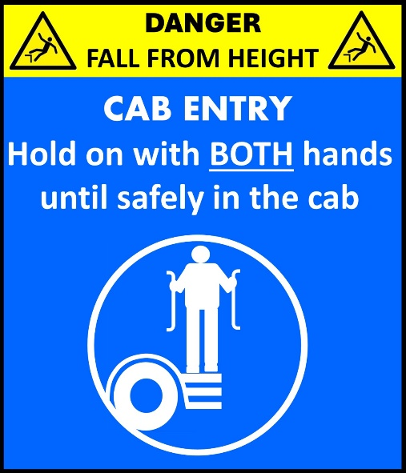  Fig 2  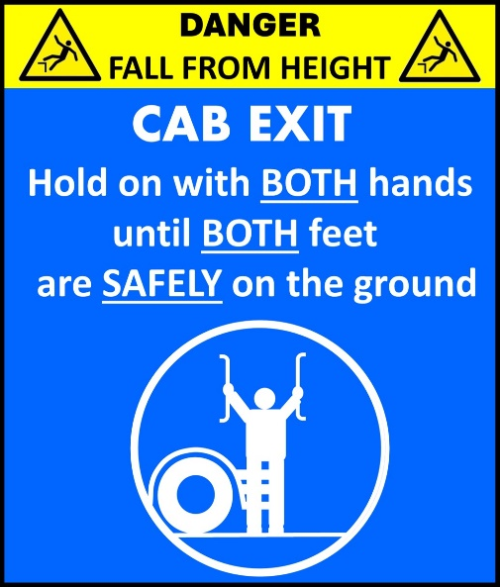  Having agreed on the new cab entry & exit safety rules, our next challenge was to ensure our drivers understood the risks inherent in the old 3 points of contact rule and learnt and implemented the new rules.  In this respect we recognised we would be attempting to change very deeply entrenched habits and therefore we needed to design a campaign that not only imparted the necessary information but also reiterated and re-enforced it over a period of months.  The training element of the campaign was delivered as a special video which alerted the drivers to the spate of incidents we’d had, explained how the root cause of these incidents was a flaw in the 3 point of contact rule, and demonstrated how to enter and exit the cab safely using the new rules.  View video by clicking on link: https://youtu.be/_ytPAULdGFM  One month after the video had been shown to the drivers, posters (see below) were displayed in the driver’s messrooms and at all weigh-bridges to remind drivers of the new rules and the key points from the video.  Fig 3  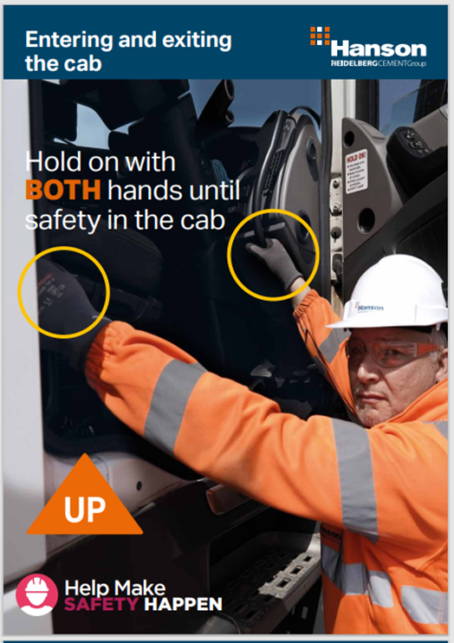  Fig 4  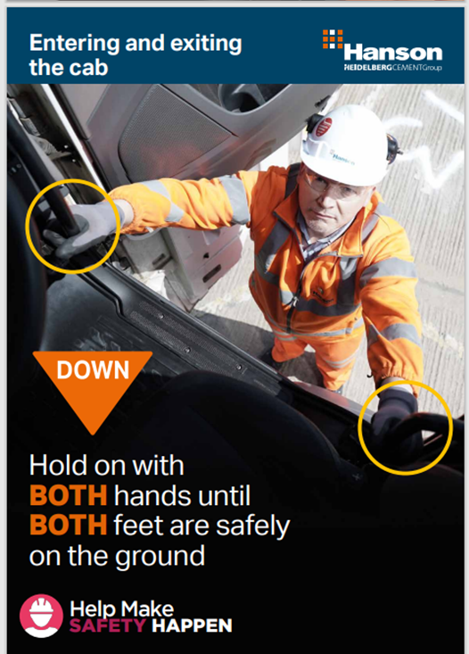  Fig 5  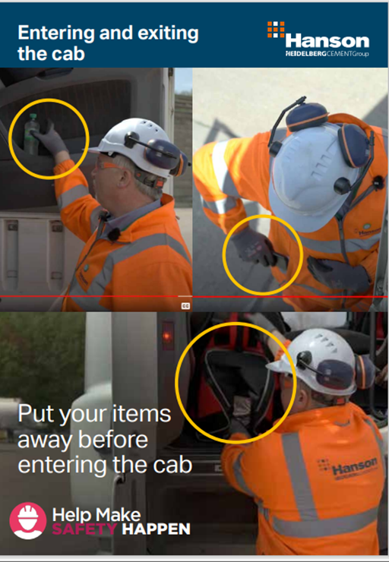  Thereafter, stickers (Fig 1&2 above) were placed on the outside and inside of all LGV cab doors. These stickers were designed in compliance with the Safety Signs and Signals Regulations thus giving the new rules legal status.  Finally, a bespoke audit tool was developed in Microsoft Forms (Fig 6 below) which was uploaded to the Distribution Department management team’s mobile phones enabling them to intensively audit and re-enforce compliance with the new rules during site visits.  Fig 6  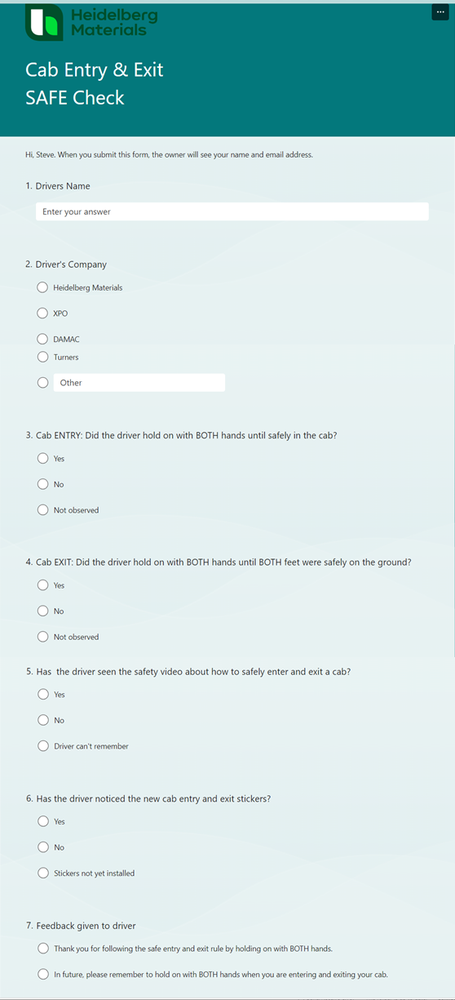
MARKS | MAX 30%

ENTRY INFORMATION
PLEASE FILL IN THE BOXES BELOW
IV. BENEFITS  Suggested 100-300 words  To complete this section you make like to consider some or all of these questions.  What are the benefits – these could apply to your organization, employees, contractors, customers, members of the public?  Extent to which there are clearly demonstrable benefits?  Extent to which this has mitigated a high potential hazard e.g. ‘The Fatal 6’?  Extent to which it has significantly changed behaviour, improved health and safety culture?  Extent to which the health and wellbeing of employees/contractors/others improved?  Extent to which it has created a significantly safer working environment?  Extent to which it has improved the competences of employees/contractors?  Extent to which it has improved the efficiency of the operation?  Do you have any statistics that reflect these benefits? | Since the new cab entry/exit rules have been introduced there have been no further falls from cabs in Heidelberg Materials Cement LGV fleet.
MARKS | MAX 40%

v. INNOVATION  Suggested 50-200 words  To complete this section you make like to consider some or all of these questions.  Does this reflect a new or innovative approach to resolving an H&S issue?  Does it reflect an enhancement or adaption of an existing concept / work practice?  Is this new for your company or site, demonstrating a willingness to improve / learn from others etc.? | This project shows the benefit of utilising specialists to analyse the root causes of injuries and injury trends.  Replacing the “3 points of contact” rule for cab entry and exit with the “hold on with both hands” rules, represents a new and innovative approach to resolve a repetitive and seemingly intractable cause of injury in our industry.
MARKS | MAX 10%

ENTRY INFORMATION
PLEASE FILL IN THE BOXES BELOW
VI. DEVELOPMENT AND TRANSFERABILITY  Suggested 50-200 words  To complete this section you make like to consider some or all of these questions.  Are there any further development plans outlined in entry – within the site or your company?  Could this idea be applied within another company, the industry or other sectors?  Has it already been adopted at other sites, companies etc.?  Has it been shared with others or are there plans to do so? | Applications within other companies: The findings of our accident analysis and the safety campaign that followed (new rules, video, posters, stickers and audit tool) could all very usefully be applied by the many other companies who currently rely on the 3 points of contact rule for cab entry and exit.  Further Developments: Following the success of the LGV campaign Heidelberg Materials are currently developing a similar campaign for safely entering and exiting yellow mobile plant at its quarries, ready-mix and asphalt plants.
MARKS | MAX 10%

VII. JUDGES COMMENT | This section will be completed by the judge who will consider how well the entry reflects the topic theme and any other factors considered to be particularly relevant.
MARKS | MAX 10%

PLEASE FILL IN THE BOXES BELOW
VIII. ‘The Fatal 6’
Does the idea help mitigate either 1 or more of ‘The Fatal 6’ and if so which ones. Please add a tick or YES in relevant boxes.
1. Contact with moving machinery and isolation |  | 4. Workplace Respirable Crystalline Silica
2. Workplace transport and pedestrian interface |  | 5. Struck by moving or falling object
3. Work at height | X | 6. Road Traffic Accidents

ENTRY INFORMATION
HAVE YOU GOT IMAGES TO SUPPORT YOUR ENTRY? | If relevant please provide brief explanation and/or titles of images provided.
Please note that it is very important to include images that will highlight your entry. This will both help judges to understand the entry and will assist in the future promotion of the entries that will be included in the Sharing Good Practice Guide and other promotional material.

Please send the images and resources as attachments along with this entry form to entries@mpahsawards.org
Images can be embedded in word documents as well but, should you choose to do this, please ensure that you also send the image file separately.

If files are over 8MB please do not attach to email but contact entries@mpahsawards.org to advise on how to transfer the files.
DO YOU HAVE ANY ADDITIONAL INFORMATION? | If relevant please provide brief explanation of resources supplied
If you wish to please include PowerPoint files, documents, sample forms or Video clips please attach them to entries@mpahsawards.org along with this form.
Please send the images and resources as attachments along with this entry form to entries@mpahsawards.org

If files are over 8MB please do not attach to email but contact entries@mpahsawards.org to advise on how to transfer the files.
WHEN YOU HAVE COMPLETED THE FORM PLEASE SAVE AS A WORD DOCUMENT AND E-MAIL TO entries@mpahsawards.org
Please note that support and guidance can be provided by contacting entries@mpahsawards.org

